- B2B Automotive Auction Platform on Azure
Architecture & Design Description
- Designed a highly available, serverless B2B automotive auction platform on Azure, supporting web and mobile clients for up to ~100 B2B partners/dealers over the first three years.
- Implemented Azure Virtual Desktop (AVD) for secure remote access by internal staff; the initial rollout focuses exclusively on AVD, with public mobile access added later.
- Backend architecture built with microservices on Azure Container Apps, exposing RESTful APIs via public ingress, allowing both AVD and mobile clients to access backend services directly. No API Gateway or Application Gateway was used initially to optimize budgeting and simplicity, given the small user base and limited geographic deployment for the first releases (Montréal and Toronto, with Vancouver planned over the next 3–4 years). The architecture was designed to support future expansion to additional cities and the introduction of a B2C module, leveraging the same backend services for mobile and web application interfaces, while the web application is exclusively intended for B2C use cases.
- Integrated external enterprise systems (GEM-DMS, EAM, CRM SaaS modules) using secure API connectors for real-time synchronization of vehicle sale data, dealer bidding, and purchases.
- Developed a simplified Azure analytics solution:
- Designed a star-schema Data Warehouse in Azure SQL Database.
- Ingested auction sales via Azure Functions into a staging area.
- Orchestrated data pipelines using Azure Data Factory to populate dimension tables from CRM, EAM, and auction sales, powering Power BI dashboards.
- Enforced identity & access management using Azure Entra ID, securing both user and service accounts.
- Network & security pattern simplified for the first deployment:
  - Public ingress to Azure Container Apps for mobile and AVD access.
  - Private subnets for database access.
  - Use of private endpoints for SaaS connectivity.
- High availability ensured within deployed regions using Azure Container Apps scaling and database redundancy, despite limited geographic scope.
Key architectural patterns applied:
- Serverless microservices
- Event-driven integration
- Multi-tenant SaaS architecture (small scale)
- Star-schema data warehouse for analytics
- Cloud-native security & private connectivity
- Cost-optimized design for small user base and limited regions
High level Architecture Diagrams

- Cloud (Azure) High level Architecture / Diagram 1: Access to the application

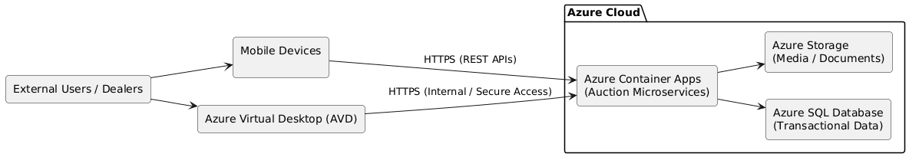

Diagram explanation:
- Public ingress on Azure Container Apps replaces API Gateway/Application Gateway for this budget-conscious, small-scale deployment.
- AVD provides internal remote access, while mobile clients access backend directly via the same public ingress.
- Backend microservices handle all auction, bidding, and reporting logic.
- Analytics pipelines ingest and transform data into the Azure SQL Data Warehouse, feeding Power BI dashboards.
- SaaS integrations remain secure via private endpoints.
Communication between Azure Virtual Desktop with Azure Container apps public ingress enabled
Understanding the Traffic Flow
- Public Ingress: When a container app has public ingress enabled, it is accessible from the public internet via a public IP address.
- AVD Access: AVD session hosts are deployed within our Azure Virtual Network (VNet).
- Accessing a Public Endpoint from within a VNet: By default, resources within a VNet can access public endpoints on the internet. Therefore, our AVD session hosts can reach the container app's public URL through the internet (outbound from VNet, inbound to the container app's public IP). This does not keep the traffic exclusively internal to the Azure backbone network.

Achieving "Internal Remote Access" via AVD:
To ensure the traffic between our AVD session hosts and the container app remains internal to our private network (Microsoft's backbone), we can use one of these two main approaches:
- Use Private Endpoints (Recommended for security): This approach maintains public ingress for external users but forces traffic from our VNet (and thus our AVD session hosts) through a private route.

Cloud Solution High Level Architecture (Diagram 2): Integration GEM-DMS system & Data warehouse solution
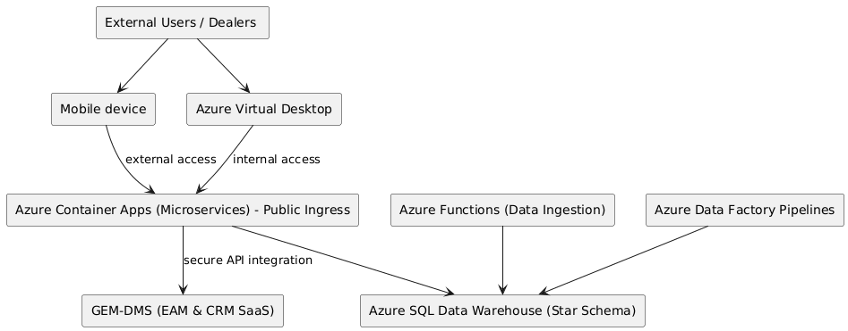

- Conceptual Architecture – B2B Automotive Auction Platform (Diagram3): High level business specifications
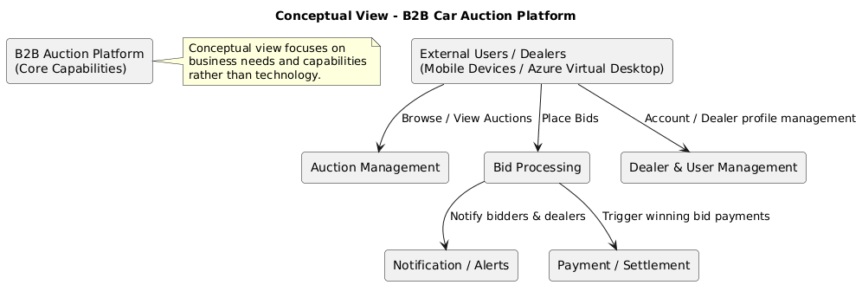
- Executive Architecture – B2B Automotive Auction Platform (Diagram 4): Highlights major containers & technology choices
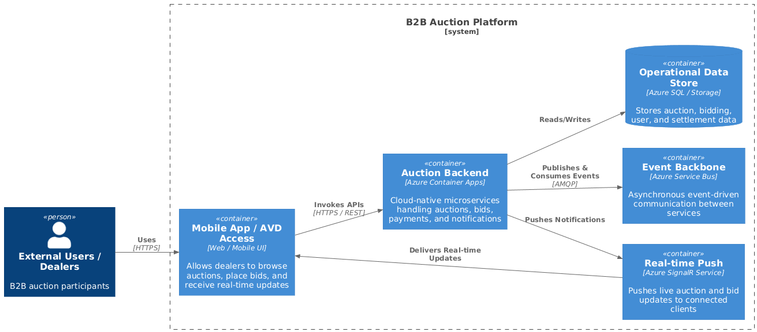
Illustrates system boundaries, major containers, and key technology choices. It complements the conceptual view by translating business needs into a high-level logical system structure.”

- Logical Architecture – B2B Automotive Auction Platform: Microservices Design & Bounded Context diagrams

- Diagram 4: Microservices design (Restful AP)

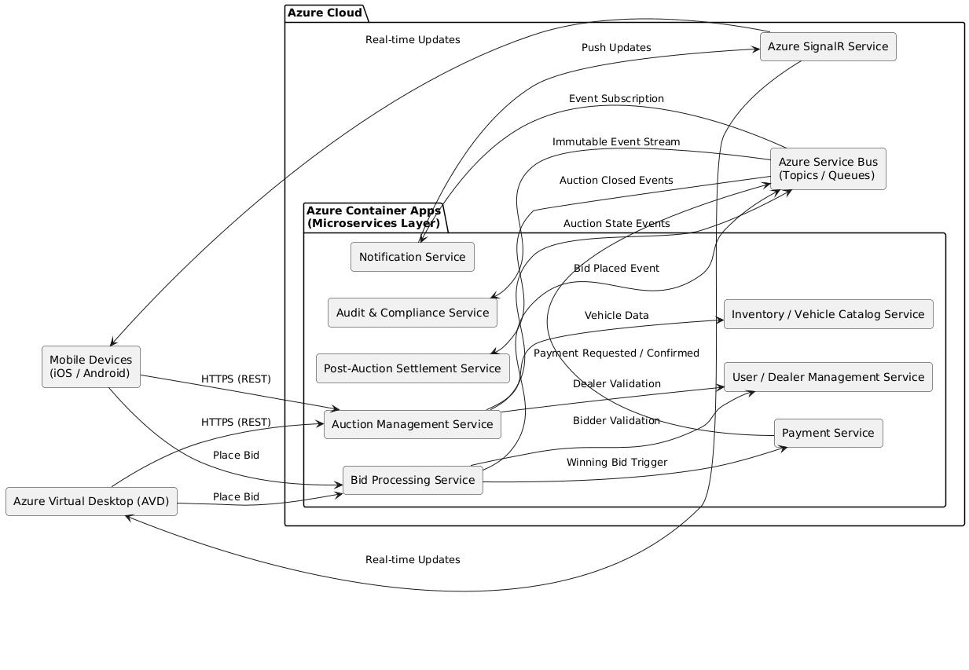

- Diagram 5: Bounded Context: Shows how the system is organized functionally, defining service responsibilities, domains, and interactions without specifying physical deployment or exact technology. Focuses on how the system works.

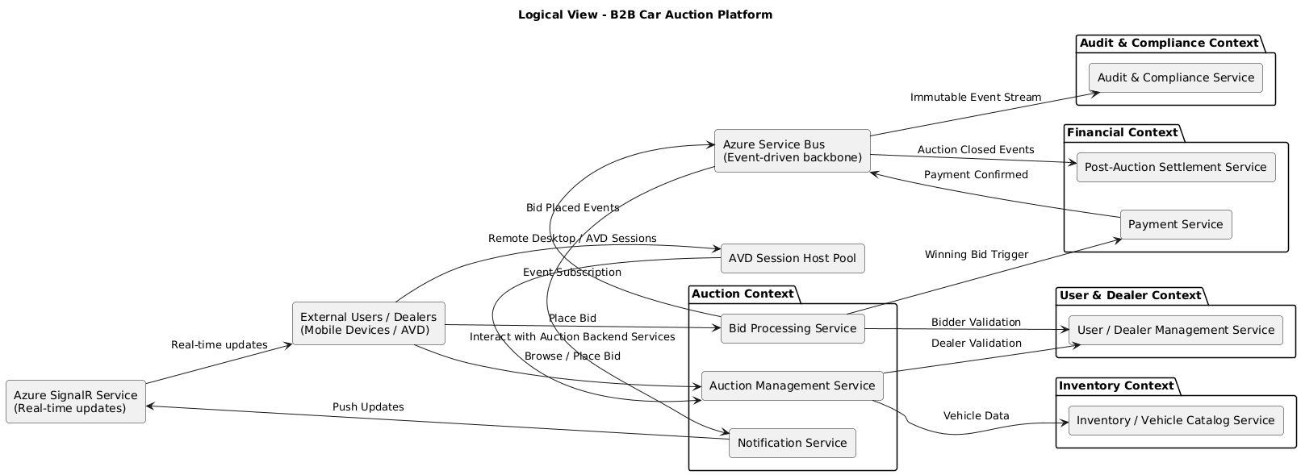

The Bounded Context Diagram is presented as a Logical View, illustrating how microservices are grouped into business domains, their responsibilities, and interactions. This complements the Conceptual and Executive Views by showing how the system works internally, without detailing deployment specifics. Microservices are grouped into bounded contexts reflecting core business domains: Auction, Financial, User & Dealer, Inventory, and Audit & Compliance. This design clarifies responsibilities, enables independent evolution, and aligns with event-driven architecture principles.”
Bounded Contexts Overview
Purpose:
- Show domain-driven boundaries
- Explain why services are separated
- Highlight future extensibility
Contexts for our platform:
- Auction Context
  - Auction Management Service
  - Bid Processing Service
  - Notification Service
- Financial Context
  - Payment Service
  - Post-Auction Settlement Service
- User & Dealer Context
  - User / Dealer Management Service
- Inventory Context
  - Inventory / Vehicle Catalog Service
- Audit & Compliance Context
- Audit & Compliance Service
Microservice Descriptions
Auction Management Service
Manages the full auction lifecycle, including creation, scheduling, state transitions, reserve rules, and auction closure. Acts as the orchestration point for auction-related business logic.
Bid Processing Service
Handles high-frequency bid submissions with concurrency control, validation, and ordering guarantees. Publishes bid events asynchronously to ensure scalability and responsiveness under peak bidding activity.
User / Dealer Management Service
Manages dealer profiles, roles, and access rules. Integrates with enterprise identity (Azure Entra ID) for authentication while maintaining application-specific authorization and dealer metadata.

Inventory / Vehicle Catalog Service
Maintains vehicle metadata, auction listings, and associated documents. Provides a normalized view of auction inventory consumed by auction and bidding services.
Payment Service
Handles payment initiation, authorization, and confirmation for winning bids. Ensures transactional integrity and publishes payment state changes for downstream processing.
Post-Auction Settlement Service
Manages post-auction workflows including settlement finalization, ownership transfer, invoicing triggers, and downstream system notifications following successful payment.
Notification Service
Subscribes to domain events and pushes real-time updates (bid changes, auction status, payment confirmation) to connected clients using Azure SignalR.
Audit & Compliance Service
Consumes immutable event streams to maintain a complete, tamper-resistant audit trail of auctions, bids, and payments, supporting traceability, compliance, and dispute resolution.

The Microservices architecture provides
- Loose coupling via Service Bus
- Event-driven design (bids, auctions, payments)
- Scalable real-time fan-out using Azure SignalR
- Single backend serving multiple client types
Service responsibilities
- Auction Management → lifecycle & rules
- Bid Processing → concurrency-safe bidding
- Payment Service → transactional boundary
- Notification Service → real-time & async messaging

Security Authentication & Authorization Flow (Diagram 7)
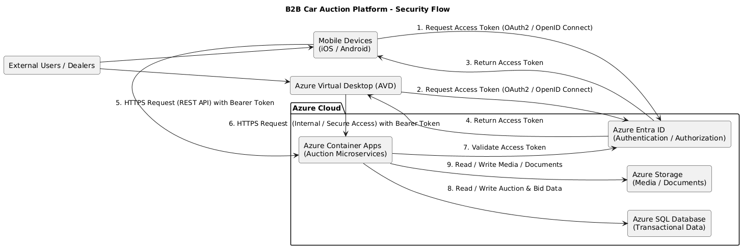
Event Flow Diagram 8: Illustrating the end-to-end user request flow and events
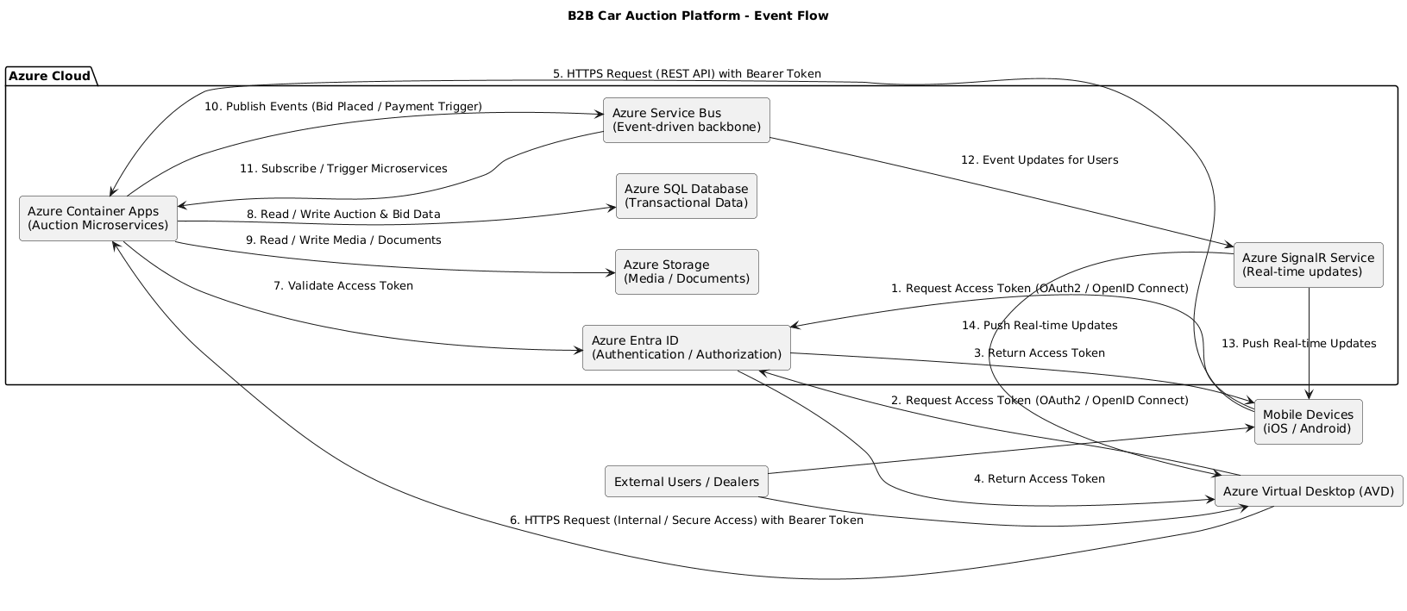
- Physical Architecture – B2B Automotive Auction Platform (Diagram 6)
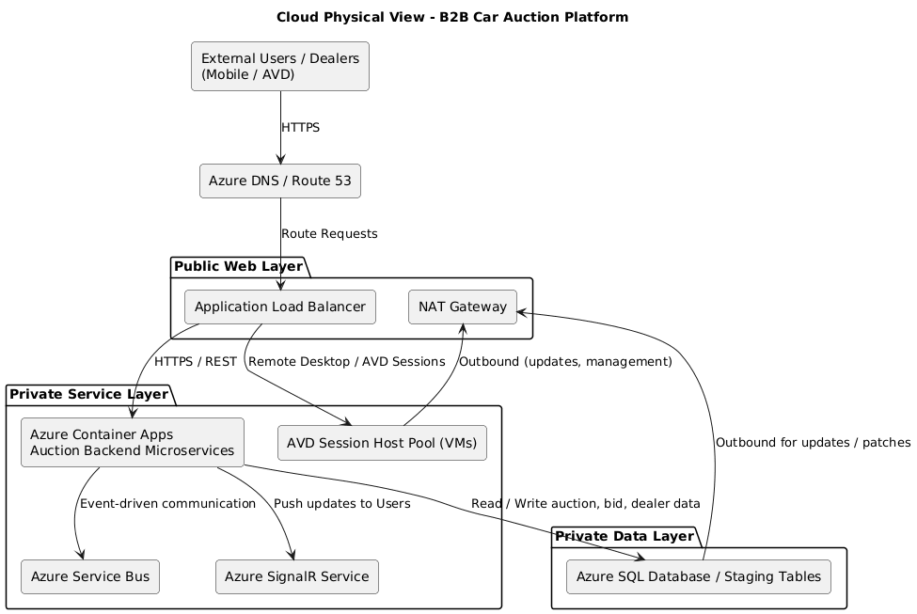
The physical view diagram
- Shows cloud infrastructure: ALB, NAT, private/public subnets (abstracted)
- Shows backend microservices, messaging, real-time updates, database
- Physical deployment concepts: secure private service layer, data layer, outbound connections
Dedicated private IP subnet for AVD session hosts:
- Isolation: Keeps VM-based session hosts (AVD) separated from containerized microservices, reducing blast radius in case of misconfigurations or security issues.
- Network Security: Allows distinct network security groups (NSGs) and routing rules for session hosts vs. microservices.
- Scaling / Maintenance: We can scale or patch session host VMs independently without affecting microservices.
- Compliance & Monitoring: Easier to monitor resource consumption, access, and logging separately.
Data warehouse star schema & KPIs Analytic view (Diagram 9): Star schema fact & dimension tables & KPIs

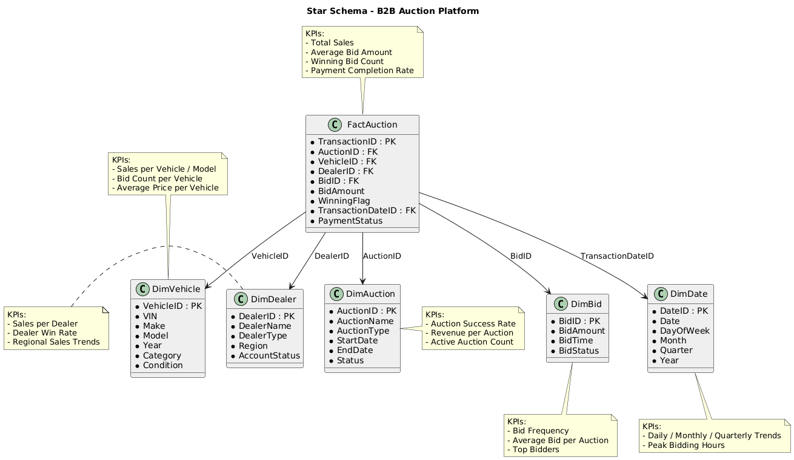

The above schema illustrates the analytical structures (data warehouse star schema fact and dimension tables) and their KPI consumption through Power BI
Conceptual Architecture View for Data Warehouse data – B2B Automotive Auction Platform (Diagram 10): Illustrates how services provide fact and dimension tables data.
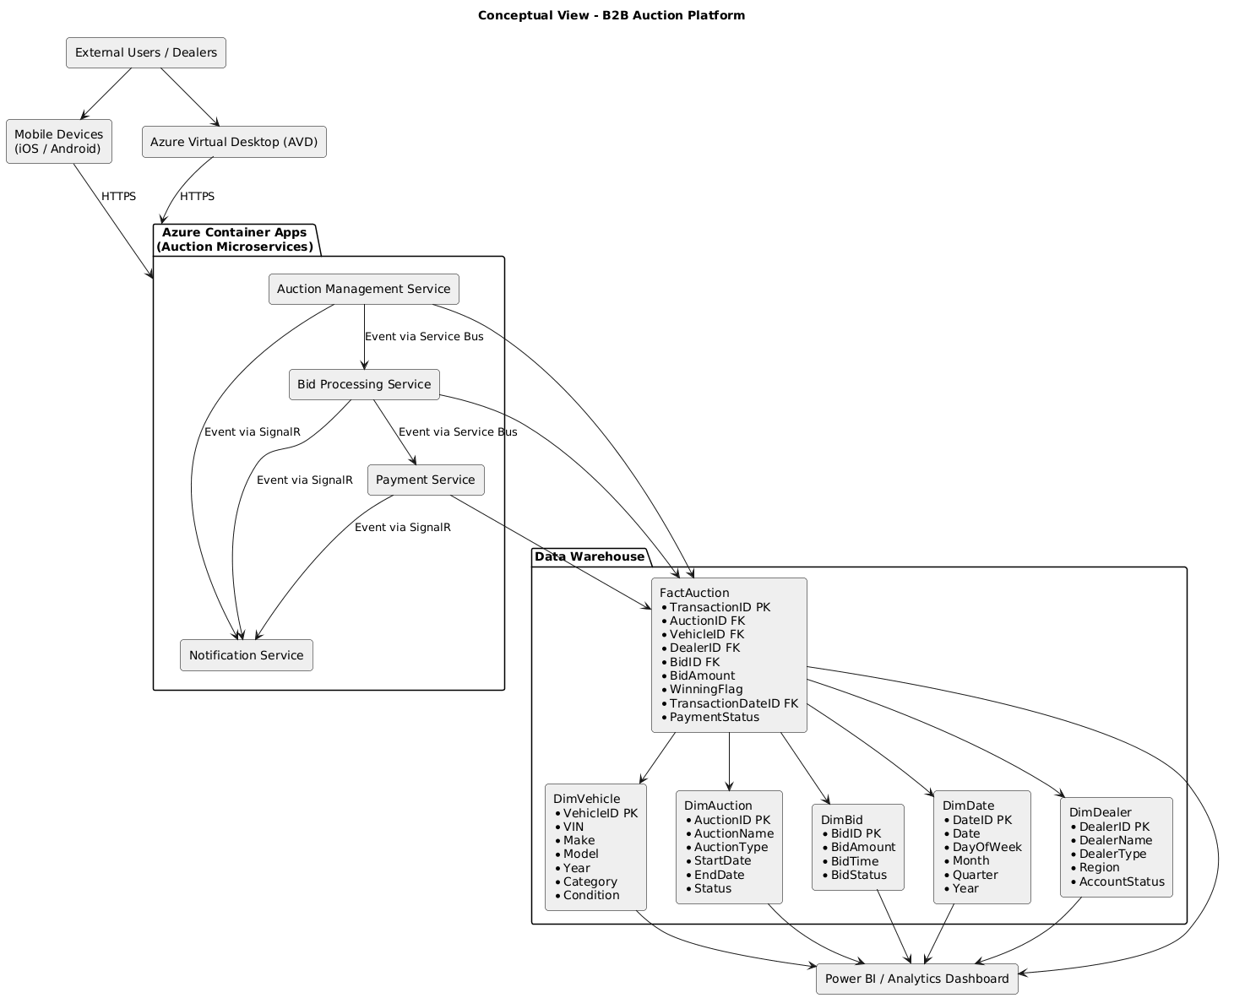
Diagram 11: Disaster Recovery solution
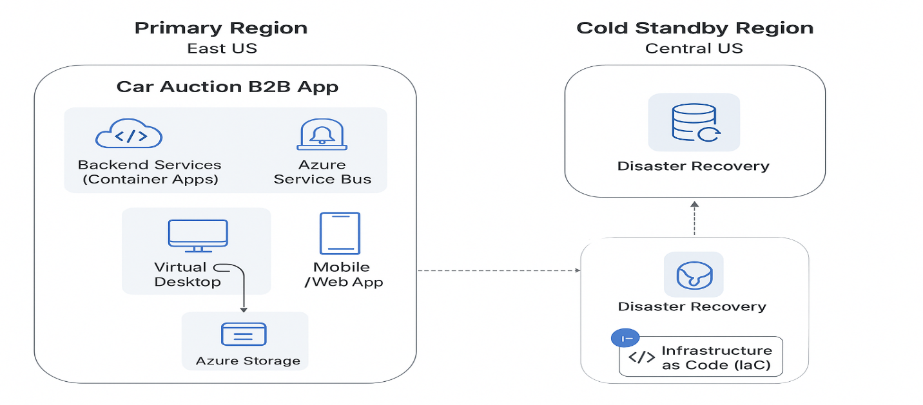
- Hotel Digital Access Platform on Amazon
Architecture & Design Description
- Responsible for architecture plans for the development and production teams supporting the LGS (Lodging Global Solution) – … Server, a multi-tenant hotel digital access solution issuing physical and digital keys.
- Designed a cloud-native, serverless architecture on AWS, targeting 250 Hyatt sites initially, with scalability to support 3,000–5,000 sites over five years.
- Backend architecture:
  - Microservices deployed as ECS Fargate tasks, fronted by the custom Ambiance API Gateway.
  - Application Load Balancer (ALB) routes requests from web apps and external services to the API Gateway.
  - Microservices communicate primarily via RabbitMQ for event-driven asynchronous messaging.
  - Aurora Serverless (PostgreSQL) provides the database layer with automatic scaling and multi-AZ redundancy.
- Digital mobile access integration:
  - Android devices use Bluetooth to unlock hotel doors, with Ambiance Server communicating securely with External SaaS to provision mobile credentials.
  - Apple devices (iPhone) use NFC for door access. Ambiance Server integrates Apple APIs and communicates with External SaaS for credential management while also interacting with the hotel PMS system to validate reservations and trigger mobile access.
  - On-site Ambiance client app communicates with door encoders via WebSocket over the hotel private network for physical key issuance.
- Web access:
  - Ambiance web app calls the API Gateway via HTTPS for administrative and operational functions.
- Scalability & fault tolerance:
  - Multi-AZ ECS Fargate deployment ensures high availability and automatic scaling for cloud microservices.
  - Aurora Serverless database scales elastically with workload.
- Security & network:
  - Private hotel IP network for sensitive on-site communications.
  - HTTPS for all external interactions and secure API calls to external SaaS for digital key delivery.
  - Role-based access control and least-privilege principles applied to microservices and database access.

Key architectural patterns applied:
- Cloud-native, serverless microservices
- Event-driven architecture via RabbitMQ (Amazon MQ)
- Multi-tenant SaaS solution
- Digital mobile access integration (Bluetooth for Android, NFC for Apple) via External SaaS
- WebSocket integration for real-time physical key encoding
- Scalable compute ECS/Fargate & database (Aurora) serverless solutions
- High availability & multi-AZ deployment for production-grade fault tolerance

Scalability & Cost-Efficiency Rationale – ECS/Fargate & Aurora
The platform was designed as a multi-tenant, cloud-native solution to support an initial onboarding of approximately 250 hotel sites (ABC_FAKE_NAME) in year one, each averaging ~250 rooms, while scaling to 3,000–5,000 customer sites over a 5-year horizon, all with similar room capacities.
Given the low annual revenue per customer site (~/year), cost control and operational efficiency were critical to ensure long-term profitability while maintaining high availability and performance.
To address these constraints, Amazon ECS with AWS Fargate (serverless containers) was selected to:
- Eliminate fixed infrastructure costs by avoiding always-on VM capacity.
- Dynamically scale compute resources based on real traffic and workload demand.
- Support granular, per-microservice scaling, allowing independent ECS task scaling per service (e.g. encoder service scaling higher than mobile delivery or digital key generation services).
- Handle peak and burst workloads efficiently, particularly during high-concurrency events such as mass check-ins, mobile key provisioning, or bulk card encoding operations.
- Simplify operations and reduce DevOps overhead, improving cost-to-serve per customer site.
On the data layer, Amazon Aurora (PostgreSQL-compatible) was chosen to complement the serverless compute model by providing:
- Elastic database scaling aligned with application load.
- High availability and fault tolerance for critical access-control data.
- Cost-efficient performance at scale, suitable for multi-tenant transactional workloads.
This fully serverless architecture (ECS/Fargate + Aurora) enabled the platform to scale precisely where and when needed, optimize infrastructure spend, and remain economically viable while supporting thousands of hotel sites and millions of digital access operations over time.

High level Architecture Diagram

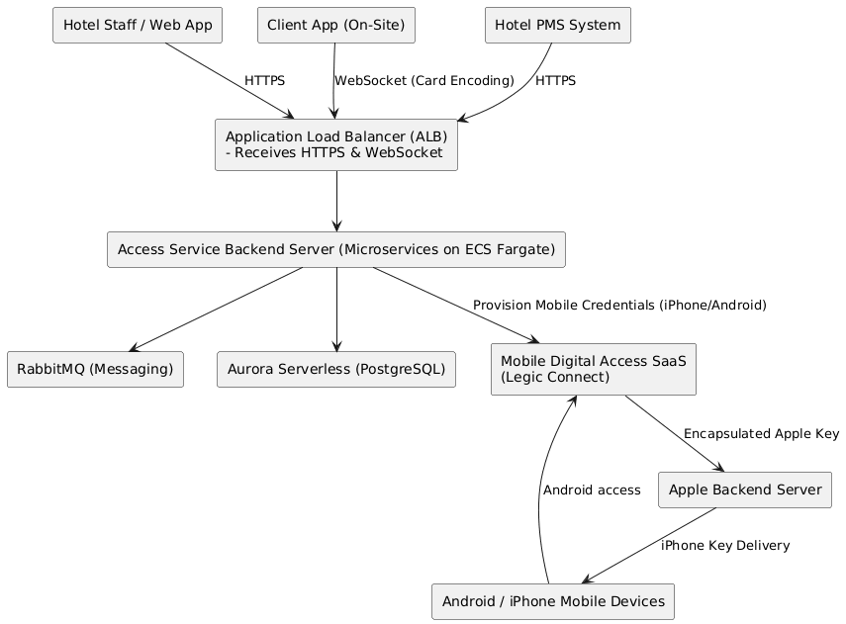

Tree-tier network:
- Public subnet: web layer with NAT Gateway
- Private subnet: service/application layer (containers/serverless)
- Private subnet: data layer (database/PaaS)
Security layers:
- Firewalls at subnet and instance level (AWS Security Groups + Network ACLs / Azure NSG + ASG)
High availability:
- Multiple Availability Zones implied for subnets
- ALB handles load balancing
API Gateway:
- Manages API-specific tasks before routing to services
Identity & DNS:
- IAM / Azure Entra ID for auth/authz
- DNS resolves requests to appropriate backend

- Digital Learning Platform
Architecture & Design Description
- Designed a digital learning platform for field employees using VR headsets and tablets, integrated with SAP ERP HCM and SuccessFactors systems.
- Data storage & management:
  - Data Lake implemented with MinIO, Elasticsearch, and Delta Lake.
  - Multi-zone storage for different stages: staging → raw → validated → curated → archive.
  - ETL pipelines orchestrated using Apache Airflow and Apache NiFi, with processing performed by Kubernetes worker pods.
- Data Warehouse / Analytics:
  - Star-schema Data Warehouse optimized in Delta Lake (Parquet on MinIO).
  - Apache Spark used to transform and aggregate data, enabling real-time actionable insights in Power BI (both Import and DirectQuery modes).
- Machine Learning pipelines:
  - Spark triggers containerized ML microservices for:
    - Content classification
    - NLP-based auto-tagging
    - Recommendation logic
  - ML outputs enrich validated datasets to power personalized learning content discovery.
- Key architectural patterns:
  - Event-driven, multi-zone data processing
  - Containerized ML microservices triggered by Spark jobs
  - Modular ETL orchestration (Airflow + NiFi)
  - Real-time dashboards via Power BI
Architecture Artifacts Summary
1. Conceptual Architecture (Business View)
Purpose
Defines what the business needs, independent of technology choices.
Key Focus
- Digital learning delivery for field employees (VR headsets & mobile devices)
- Integration with enterprise HR systems for user, role, and training management
- Centralized learning data platform supporting both initial bulk data onboarding and continuous ingestion
- Analytics and machine-learning–driven personalization to improve learning effectiveness
Audience
- Business stakeholders
- Product owners
- Non-technical leadership

2. Executive Architecture (Decision View)
Purpose
Supports executive and architectural decision-making by presenting system boundaries, responsibilities, and scalability considerations.
Key Focus
- Clear separation of learning experience, ingestion, analytics, and ML services
- Explicit support for bulk + continuous ingestion paths
- Modular, evolutive ML adoption (classification, NLP tagging, recommendations)
- Analytics as a strategic enabler for workforce readiness and compliance
Audience
- Executives
- Enterprise architects
- Program sponsors

3. Logical Architecture (System Interaction View)
Purpose
Explains how the system works from an end-to-end functional perspective.
Key Focus
- Integration of learning devices with HR systems
- Data ingestion orchestration (initial loads and ongoing updates)
- Multi-zone data lake design (staging, raw, validated, curated, archive)
- Spark-based processing and enrichment pipelines
- ML-enabled content classification and recommendation flows
- BI consumption using both Import and DirectQuery patterns
Audience
- Solution architects
- Senior engineers
- Data engineers

4. Physical Architecture (Deployment & Infrastructure View): The physical architecture is not covered in this document for this project, as it depends on the corporation’s existing production environment, which cannot be disclosed in this presentation.
Purpose
Describes where and on what the solution runs.
Key Focus
- Containerized deployment on Kubernetes
- Apache NiFi and Airflow for continuous and bulk ingestion orchestration
- Apache Spark for batch and streaming processing
- Delta Lake on MinIO object storage with open formats (Parquet)
- Containerized ML microservices
- Elasticsearch for search and indexing
- Power BI for analytics consumption
Audience
- Platform engineers
- Cloud architects
- Operations and DevOps teams

- Conceptual Architecture – Digital Learning Platform (Diagram 1): This diagram covers the high-level business specifications required for this project and is used to align stakeholders on scope and objectives. Business-oriented, technology-agnostic view describing what the platform delivers.

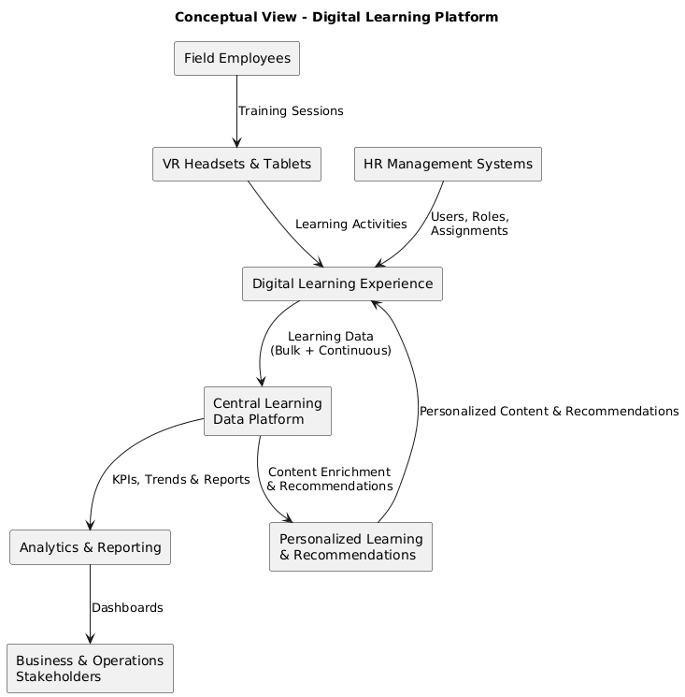
The solution enables a digital learning ecosystem for field employees, supporting immersive training via VR headsets and tablets. The platform integrates enterprise HR systems to manage users, roles, and training assignments, while capturing learning activity and operational telemetry.
Training content and usage data are centralized into an enterprise data platform that supports both historical analysis and near-real-time insights. Advanced analytics and machine learning capabilities enrich learning content through automated classification, tagging, and recommendation, enabling personalized learning journeys.
The platform supports two ingestion modes:
- Bulk ingestion for initial historical data loads
- Continuous ingestion for ongoing learning events and updates
Business stakeholders consume insights through interactive dashboards to measure training effectiveness, compliance, and workforce readiness.
Conceptual View – Key Business Capabilities
- Digital learning delivery (VR, mobile & tablet)
- HR system integration
- Centralized learning data platform
- Historical + continuous data ingestion
- Analytics and reporting
- Personalized learning recommendations
No technology names here — this is intentional
- Executive Architecture – Digital Learning Platform (Diagram 2): High-level view for management and sponsors, focusing on scale, value, and risks.
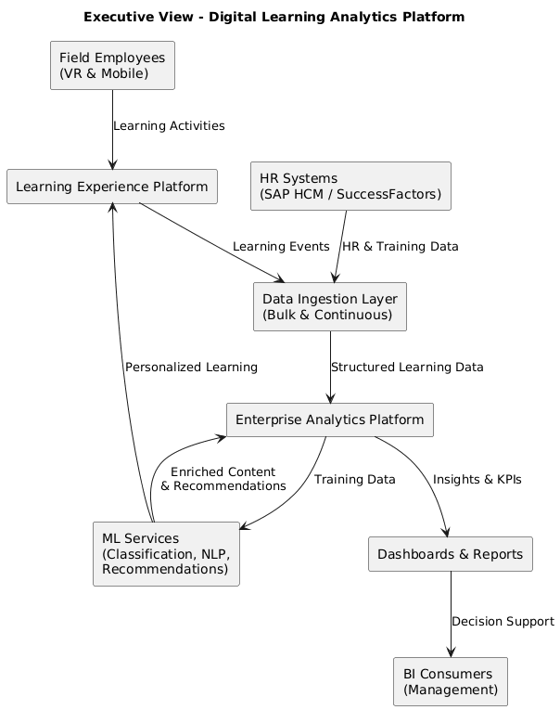
The proposed architecture establishes a scalable digital learning and analytics platform designed to support field employees across multiple regions. The solution integrates enterprise HR systems with immersive learning devices and consolidates training data into a centralized analytics platform. The architecture supports both initial bulk data onboarding and continuous data ingestion, ensuring a smooth transition from legacy data to real-time operational insights. The platform is designed for horizontal scalability, enabling growth in users, learning content, and analytics workloads without architectural redesign.
Machine learning capabilities are introduced as modular services, allowing progressive adoption of advanced features such as content classification, NLP-based tagging, and recommendation engines. The solution minimizes vendor lock-in through containerized processing and open data formats, while enabling executive visibility through real-time dashboards that support workforce planning, compliance tracking, and training optimization.
Executive-Level Decisions Highlighted
- Support for bulk + streaming ingestion
- Scalability and future growth
- Modular ML adoption (no big-bang risk)
- Analytics value for leadership
- Technology neutrality / portability
This is the view executives actually read.
- Logical Architecture – Digital Learning Platform (Diagram 3, 4, 5, 6 & 7)
- High Level View (Diagram 3)

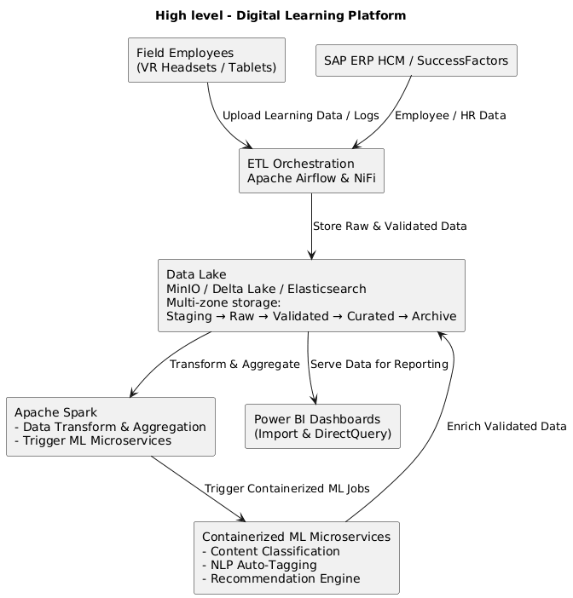
- High-level Logical View (Diagram 4)

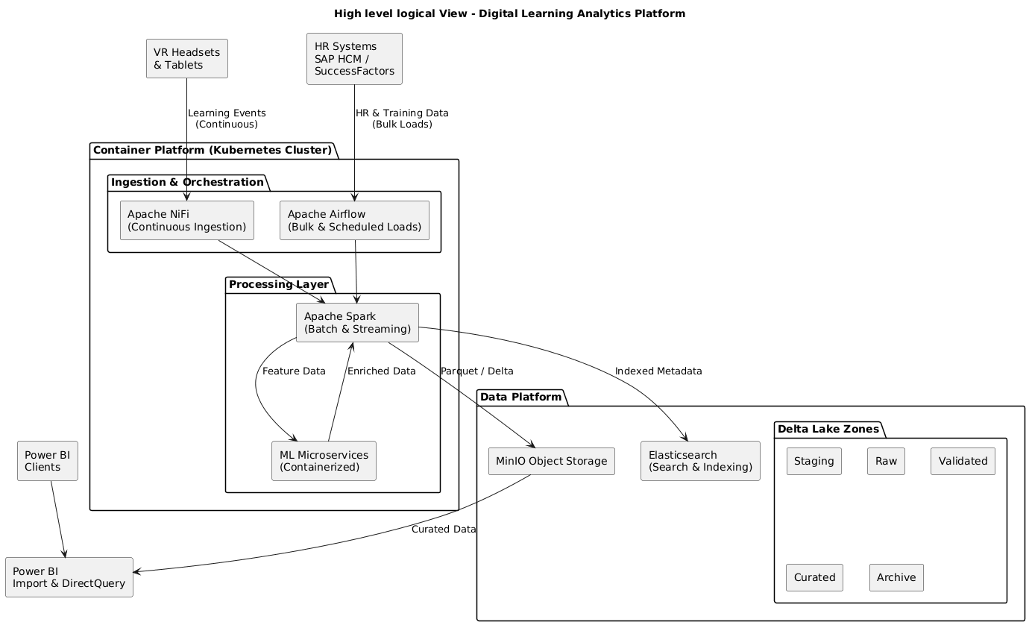
Logical View covers
- Data ingestion pipelines (bulk + continuous)
- Orchestration (Airflow, NiFi)
- Processing (Spark)
- Storage zones (staging → curated)
- ML enrichment pipelines
- BI consumption (Import + DirectQuery)
  - Logical View with Data Flow (Diagram 5): Within this diagram, “C” designates continuous flows, and “B” designates initial bulk flow events.
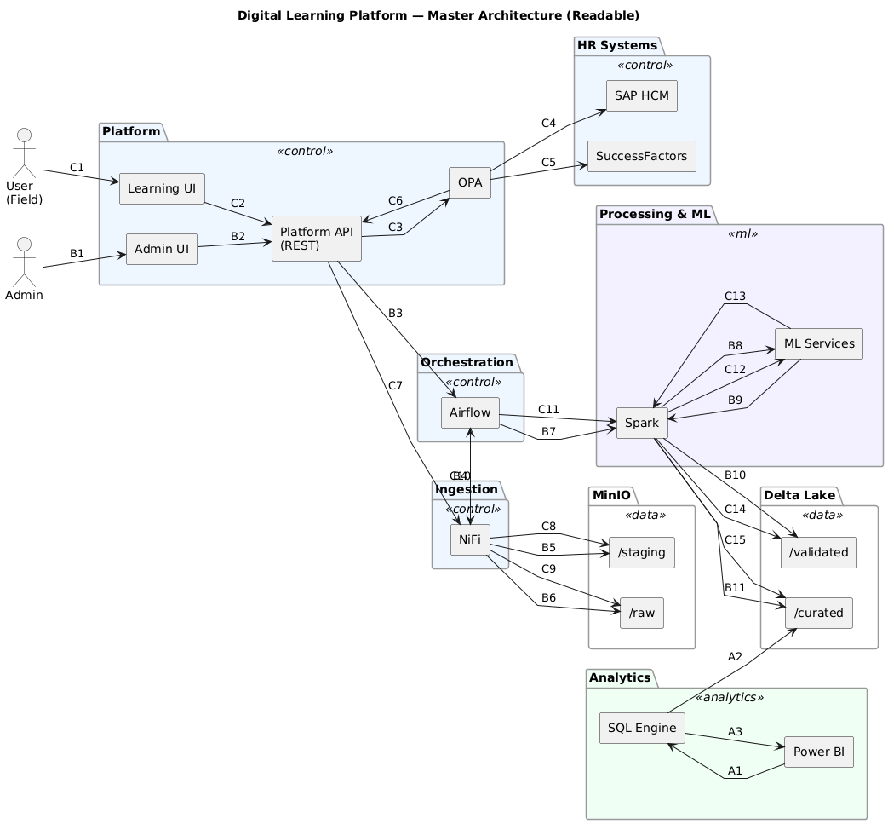
- Microservices Design Logical View (Diagram 6)
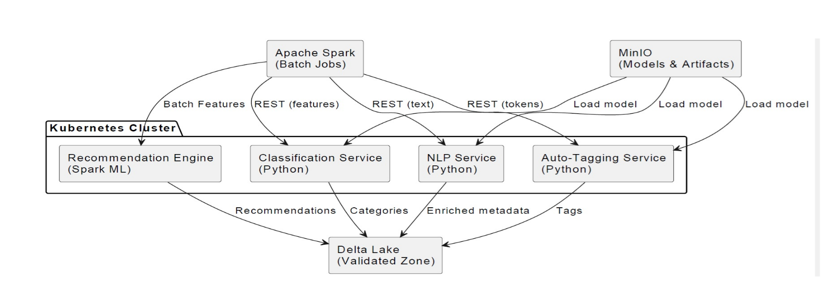
  - Microservices data flow (Diagram 7): The following diagram covers the continuous flow
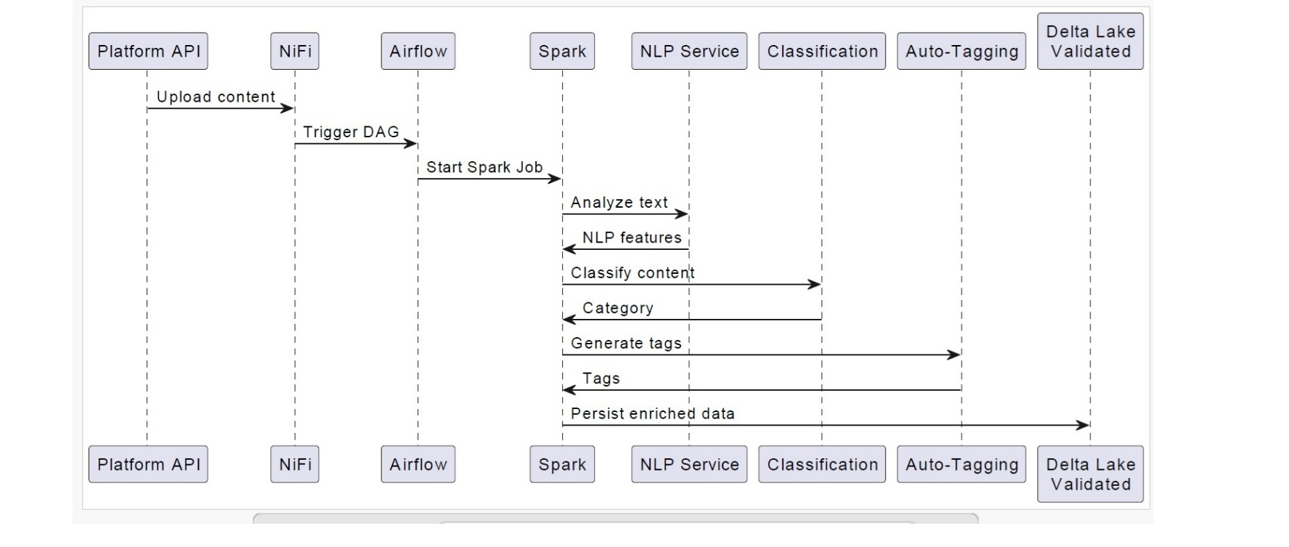
It shows systems, components, and interactions:
- VR devices, tablets
- SAP HCM / SuccessFactors
- Data Lake zones (staging, raw, validated, curated, archive)
- Airflow, NiFi, Spark, Kubernetes, ML microservices
- Power BI consumption modes
It explains how the system works, data flows, and responsibilities.
The logical architecture describes the functional architecture of the digital learning and analytics platform, detailing how learning content, usage telemetry, and operational data are ingested through batch and continuous pipelines, validated and enriched via ETL processes, and processed by analytics and ML services. It illustrates interactions between data ingestion components (NiFi, Airflow), processing engines (Spark), storage layers (Data Lake zones and analytical models), and consumption services (Power BI, ML-driven recommendation services), independently of underlying infrastructure and deployment topology.
Policy Enforcement & Governance (OPA)
Open Policy Agent (OPA) was used as a centralized policy-as-code engine to enforce governance, security, and data access rules across the analytics and machine learning platform.
OPA policies defined fine-grained authorization rules for data access, feature consumption, and ML pipeline execution, ensuring consistent enforcement across Apache Spark jobs, streaming pipelines, orchestration workflows, and API-based services.
By externalizing authorization logic from application code, OPA enabled declarative policy management, version-controlled governance, and environment-independent enforcement, supporting regulatory compliance, least-privilege access, and auditable decision-making across both batch and real-time workloads. OPA is part of the control plan.
This is where OPA is used.
OPA evaluates:
- User attributes (role, job function, skill level)
- Content metadata (difficulty, compliance level, language)
- Context (device type, location, training phase, prerequisites)
Example OPA decision questions:
- Can a field technician access advanced VR training?
- Can an employee access safety training without prior certification?
- Is this content restricted to a specific region or job role?
- Is access allowed only after completing prerequisite modules?
OPA makes the final policy decision
Typical flow:
Employee → Learning App → Backend API
→ OPA (policy decision)
→ Content Service (allowed / denied)
OPA is not replacing IAM. OPA is augmenting it where IAM becomes too rigid or coarse.
OPA is used when authorization depends on:
- Multiple attributes (user + content + context)
- Dynamic conditions
- Business rules that change frequently
- Decisions beyond “role = X”
OPA is commonly used in three additional places in our platform:
- Service-to service authorization like can Recommendation service access learner performance
- Data access governance (analytics & ML) to enforce data-level policies like Training data eligibility
- Lifecycle & automation for enforcing governance in ML workflow like which models ca be promoted to production or which features are allowed for inference.

- Analytic Architecture – Digital Learning Platform (Diagram 8, 9 & 10)

  - Storage & Lakehouse Metadata (Diagram 8): Metadata supporting storage management, search and indexing activities, machine learning pipelines, and BI & analytics consumption.

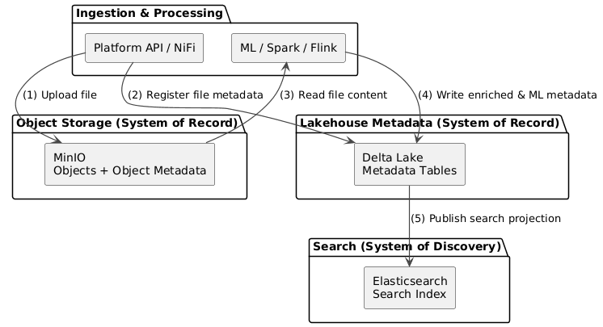

  - Conceptual View - Digital Learning with Analytics with KPI Callouts (Diagram9): Illustrates business capability map

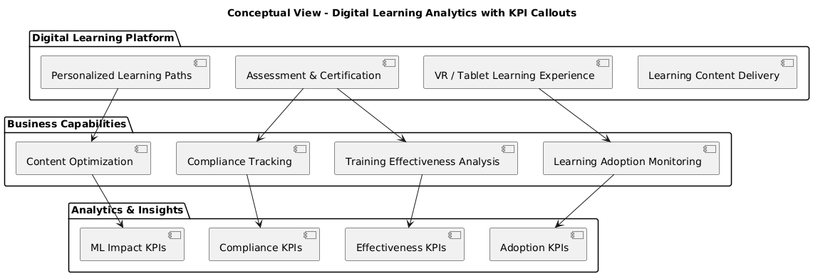

  - KPI Taxonomy Conceptual View (Diagram 10)

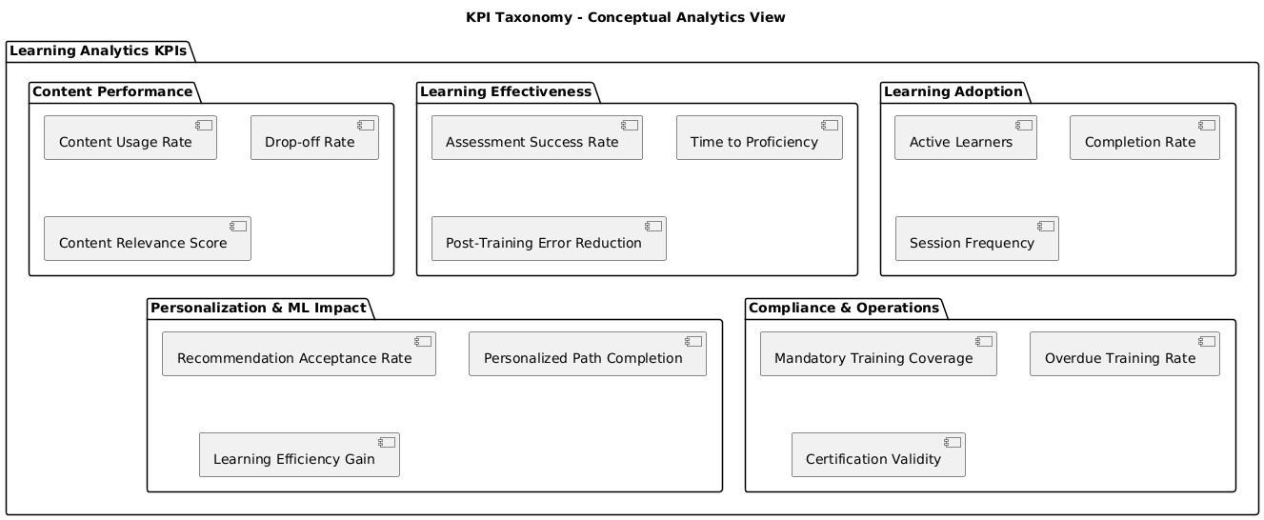
Overview
The Digital Learning Platform is designed to support field employees through personalized, role-based learning experiences, while providing management and business stakeholders with actionable insights on learning effectiveness, engagement, and workforce readiness.
At a conceptual level, the platform integrates content management, learning delivery, analytics, and intelligence capabilities into a unified business ecosystem, independent of underlying technologies.
Core Business Capabilities
1. Learning Content Management
This capability enables the organization to centrally manage learning materials (VR modules, videos, documents, interactive content) and maintain content lifecycle governance.
Key business functions
- Content upload and versioning
- Content classification and tagging
- Multilingual and multi-format support
- Content lifecycle management (draft, published, archived)

KPI Callouts
- Number of active learning materials
- Content reuse rate
- Content freshness index (updated vs outdated content)
2. Learning Delivery & User Experience
This capability focuses on delivering learning content to employees through VR headsets and tablets, adapted to their role, context, and assigned responsibilities.
Key business functions
- Role-based content access
- Personalized learning paths
- Multi-device learning experience
- Offline and field-friendly access
KPI Callouts
- Active learners per period
- Learning completion rate
- Average learning time per employee
- Device usage distribution (VR vs tablet)
3. User & Workforce Context Management
This capability integrates HR systems (SAP HCM, SuccessFactors) to contextualize learning activities based on organizational structure and employee profiles.
Key business functions
- Employee role and position alignment
- Organizational hierarchy awareness
- Project and assignment-based learning eligibility
- Compliance-driven learning assignment
KPI Callouts
- Learning coverage per role
- Mandatory training compliance rate
- Learning adoption by department

4. Learning Analytics & Performance Monitoring
This capability provides visibility into learning usage, effectiveness, and outcomes, transforming raw activity data into business-relevant metrics.
Key business functions
- Learning activity tracking
- Aggregated usage analytics
- Performance trend analysis
- Executive dashboards and reporting
KPI Callouts
- Engagement score (sessions, duration, completion)
- Learning effectiveness indicators
- Skill progression trends
- Correlation between learning and operational KPIs
5. Intelligent Content Enrichment (AI / ML)
This capability enhances learning content using automated intelligence, improving discoverability and relevance without manual effort.
Key business functions
- Automated content classification
- Auto-tagging and keyword extraction
- Learning material categorization
- Metadata enrichment for search and analytics
KPI Callouts
- Auto-tagging accuracy rate
- Search success rate
- Reduction in manual content curation effort
6. Personalized Recommendation & Guidance
This capability supports guided learning by proactively suggesting relevant materials to employees based on their behavior, role, and learning history.
Key business functions
- Behavior-based recommendations
- Role and project-based suggestions
- Continuous learning guidance
- Learning gap identification
KPI Callouts
- Recommendation adoption rate
- Content relevance score
- Repeat engagement after recommendation
Business Value Summary
From a conceptual standpoint, the platform enables:
- Improved workforce readiness through targeted learning
- Higher engagement via personalized and immersive experiences
- Operational insight through analytics-driven decision making
- Reduced content management overhead through automation
- Continuous learning culture aligned with business objectives
This conceptual view abstracts implementation details and instead highlights what the business can do, how value is created, and which KPIs measure success, forming the foundation for logical and physical architecture views.

How the Data Is Used End-to-End (Narrative Flow)
- User interactions generate learning and platform events
- Events are ingested into the Data Lake (Bronze)
- Data is curated into Silver/Gold Lakehouse layers
- KPIs are computed and stored in Warehouse star schemas
- ML pipelines consume features from the Feature Store
- Metadata enables governance, discovery, and trust
- Power BI consumes certified KPI datasets

The platform separates analytical persistence concerns by design: raw and curated data is stored in a Lakehouse for scalability and reprocessing, business KPIs are materialized in a star-schema warehouse for BI consumption, and ML features are managed through a dedicated feature store, all governed by a centralized metadata layer.”

7. Analytical Storage Layers
Our analytical architecture uses multiple analytical persistence layers, each optimized for a specific purpose:
Data Type | Primary Storage | Purpose
Raw events & logs | Data Lake (Bronze) | Traceability, replay, reprocessing
Curated analytical data | Lakehouse (Silver / Gold) | BI, KPIs, analytics
KPI aggregates | Star Schema (Data Warehouse) | Power BI, executive dashboards
Feature data (ML) | Feature Store (Lakehouse-backed) | Online & offline ML
Metadata | Metadata & Governance Layer | Discovery, lineage, orchestration
7.1 Data Lake / Lakehouse (Bronze, Silver, Gold)
This is the system of record for analytics.
Stored here:
- Learning events (views, clicks, completions)
- Assessment attempts and results
- Recommendation interactions
- Platform usage telemetry
- Operational business events
Why:
- Schema evolution
- Reprocessing capability
- Supports batch, micro-batch, and streaming
- Shared foundation for BI + ML
Example datasets:
- learning_events_bronze
- learning_sessions_silver
- content_performance_gold
- learner_outcomes_gold

7.2 Data Warehouse / Star Schema (Gold KPI Layer): This is where Power BI–ready KPIs live. Used for:
- Executive dashboards
- Operational reporting
- Cross-domain KPIs
Stored here:
- Fact tables with aggregated metrics
- Dimension tables for slicing and dicing
Example Star Schema
Fact tables
- FactLearningActivity
- FactAssessmentResults
- FactRecommendationUsage
Dimension tables
- DimLearner
- DimContent
- DimTime
- DimPlatform
- DimBusinessUnit
KPIs from our taxonomy (usage rate, drop-off rate, success rate, etc.) are materialized here, not calculated on the fly.
Mapping our KPI Domains to Storage
Examples
- Content usage rate
- Drop-off rate
- Session duration
- Completion rate
Storage
- Raw events → Lakehouse (Silver)
- Aggregated KPIs → FactLearningActivity (Star Schema)
Consumption
- Power BI
- Product analytics dashboards
Business Capabilities KPIs
Examples
- Recommendation acceptance rate
- Personalized path completion
- Learning effectiveness score
Storage
- Feature-level data → Feature Store (Lakehouse-backed)
- Aggregated KPIs → FactPersonalizationImpact
Consumption
- Power BI (aggregated)
- ML monitoring dashboards
- Model evaluation pipelines

- Metadata: Where It Fits in the Architecture
It is managed by a dedicated metadata layer that spans:
- Metadata Types
Metadata Type | Examples
Technical | Schemas, partitions, file formats
Operational | Pipeline runs, freshness, SLA
Business | KPI definitions, ownership
ML Metadata | Features, model versions
BI Metadata | Dataset lineage, reports

Metadata supports Search & discovery, Lineage (source → KPI → dashboard), ML pipeline automation, semantic consistency
A recommendation model improves learning outcomes.
- Feature metadata model improves learning outcomes
- Pipeline metadata triggers retraining on new data
- Model metadata tracks performance improvements
- Prediction results are written back to the Lakehouse
- KPI metadata defines “Recommendation Acceptance Rate”
- Power BI consumes certified KPI datasets
- Lineage metadata links model → KPI → dashboard
Same metadata layer supports ML automation and BI consistency.
A centralized metadata layer enables end-to-end automation of machine learning pipelines while ensuring semantic consistency across BI and analytics consumption, providing lineage, governance, and trust from raw data ingestion to KPI dashboards.

Digital Learning Platform – Architecture Evolution 2019 → 2025 (supporting Amazon deployment)
1. Overview of 2019 Architecture
In 2019, the digital learning platform for field employees leveraged batch-oriented ETL pipelines and micro-batch processes for content ingestion, personalization, and reporting:
- Data Ingestion: Apache NiFi handled bulk (initial loading to staging area) and micro-batch ingestion from SAP ERP HCM, SuccessFactors, VR headset logs, and tablets.
- Processing & Orchestration: Apache Spark (on EMR for Amazon & Kubernetes for on-prem or hybrid deployments scenarios) performed batch and micro-batch transformations, and workflows were orchestrated using Apache Airflow.
- Storage Layer: A Delta Lake architecture on MinIO (S3-compatible) organized data across multiple zones: staging, raw, validated, curated, and archive.
- Analytics: Star-schema Data Warehouse enabled actionable insights via Power BI (Import and DirectQuery modes).
- ML Features: Spark-based containerized ML microservices performed content classification, NLP-based auto-tagging, and recommendation logic on validated datasets.
Limitations in 2019: Micro-batch processing was bound to Spark jobs and NiFi, limiting true real-time streaming and online ML predictions. Airflow, while effective for batch orchestration, lacked native support for continuous streaming workflows.
2. Architecture Evolution in 2025:
By 2025, the platform evolved to handle continuous streaming, online ML predictions, and increased flexibility in orchestration:
- Streaming & Micro-batch:
  - Apache Flink was introduced to handle continuous ingestion and real-time processing, replacing Spark micro-batch for streaming workloads. Apache Flink is considered for real-time personalization, event-driven recommendations, or sub-second analytics (if it is requested as core business requirements).
  - NiFi continued to support initial bulk loads, ensuring backward compatibility with historical batch workflows.
  - Kafka / MSK or Kinesis were used to buffer events for Flink pipelines.
- Processing & ML:
  - Apache Spark moved to EKS (Kubernetes) to perform batch processing and ML model training.
  - Containerized ML microservices could now support online predictions, enabling real-time content personalization for employees.
- Orchestration:
  - Dagster was introduced as an alternative to Amazon MWAA(Managed Workflow for Apache Airflow), offering better integration with streaming pipelines, dependency tracking, and observability.
  - Airflow/MWAA remained optional for batch scheduling, providing flexibility.
- Storage:
  - Delta Lake remained the foundation, now complemented by Iceberg tables for enhanced schema evolution and incremental updates.
  - Data zones (staging, raw, validated, curated, archive) persisted, with streaming ingestion writing directly to raw and validated layers.
- Adding an Explicit Managed Feature Store
  - Real-time personalization, Streaming ML features, Online inference etc.
- Analytics & KPIs:
  - Power BI dashboards now reflect near real-time KPIs, including dynamic metrics for VR content engagement, employee progress, and personalized recommendations.
  - Online ML predictions enrich KPIs, allowing adaptive learning experiences.
- Key Architectural Decisions / Architecture Decision Records (ADRs):
  - Micro-batch workloads from 2019 migrated to Flink for true streaming.
  - Dagster adopted for superior orchestration of streaming pipelines.
  - Spark retained for batch / ML, ensuring high performance for large dataset computations.
  - Explicit feature management to support real-time inference.
3. Summary of Changes
Aspect | 2019 | 2025 Evolution
Ingestion | NiFi (Bulk + Micro-batch) | NiFi (Bulk) + Flink (Streaming / Micro-batch)
Streaming | N/A | Flink handles real-time event processing
Batch / ML | Spark (Batch + Micro-batch) | Spark on EKS (Batch + ML), Flink handles micro-batch
Orchestration | Airflow | Dagster or MWAA (batch + streaming)
Storage | MinIO + Delta Lake | S3 / MinIO + Delta Lake + Iceberg
Analytics / BI | Power BI (Import / DirectQuery) | Power BI near real-time dashboards
ML / Personalization | Containerized ML microservices | Online ML predictions, personalized learning
This evolution enabled real-time analytics, online ML-driven content recommendations, and flexible orchestration, while maintaining backward compatibility for historical bulk data ingestion.
High level Architecture Diagrams
The following diagram shows involved actors for both 2019 and 2025. What is changing in 2025 is the architecture for continuous ingestion.
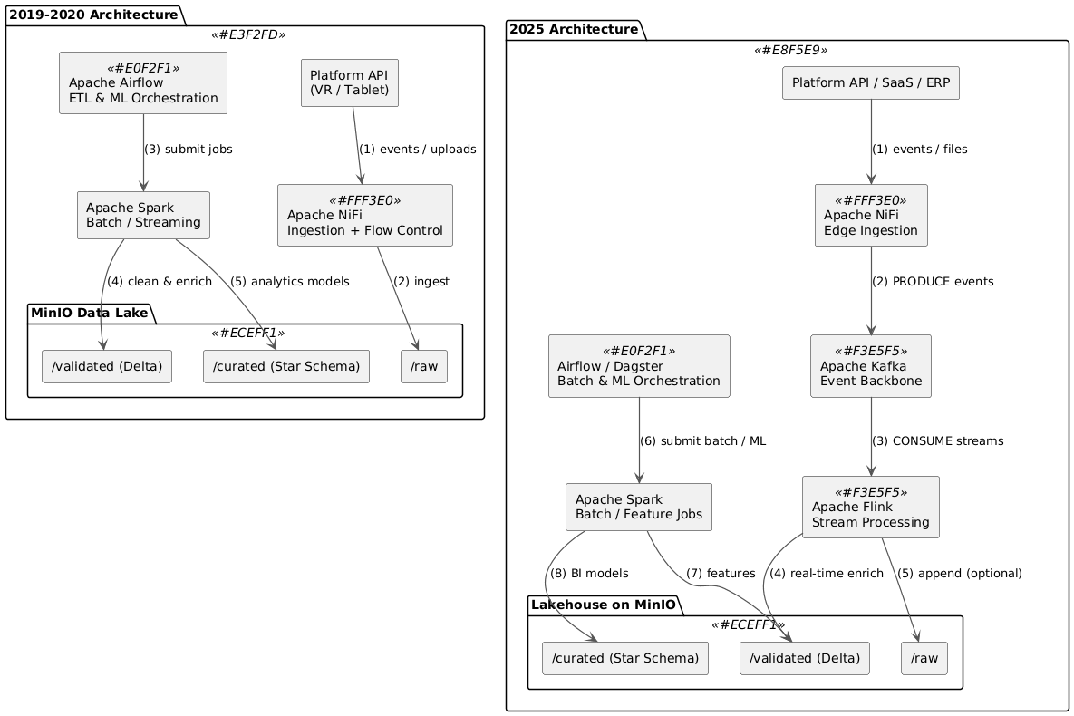
ADR (Architecture Decision Record) – Micro-batch → Flink
Title: Migration from Spark micro-batch to Flink for real-time streaming
Context:
- 2019 architecture used Spark micro-batch to handle near-real-time events.
- Spark micro-batch was sufficient at small scale but lacked native streaming semantics, event-time handling, and low-latency processing.
Decision:
- Introduce Apache Flink in 2025 for streaming ingestion.
- Retain Spark for batch & ML, and NiFi for bulk ingestion.
Consequences:
- Micro-batch processing is either migrated to Flink (true streaming) or implemented as high-frequency batch in Spark.
- Better event-time handling, stateful processing, and exactly-once guarantees.
- Clear separation of responsibilities improves scalability, maintainability, and cost efficiency.
The following 2 diagrams describe the architecture supporting Amazon Cloud deployment. In the first diagram, both 2019 and 2025 approaches are shown for the initial bulk phase and continuous ingestion.
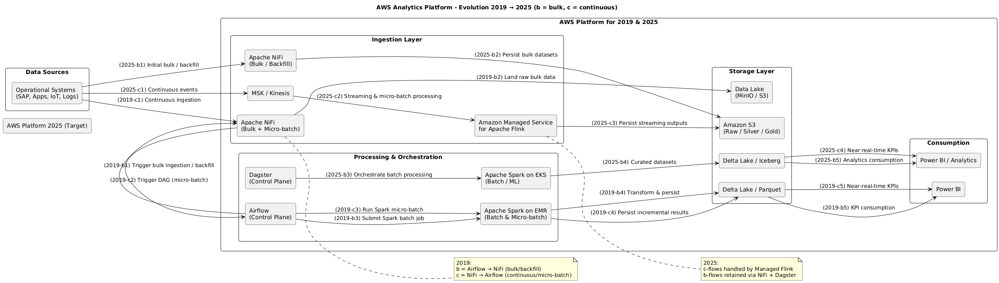
In 2019, Apache NiFi orchestrated bulk and micro-batch ingestion by triggering Airflow DAGs that executed Spark jobs (on EMR for Amazon cloud & on Kubernets for on-prem or hybrid deployment scenarios) providing near-real-time analytics latency suitable for reporting workloads, while event-driven streaming and message brokers were introduced later as part of the 2025 modernization.
In the second diagram, we illustrate the evolution between 2019 and 2025 approaches showing the changes made for continuous & micro-batch ingestion.
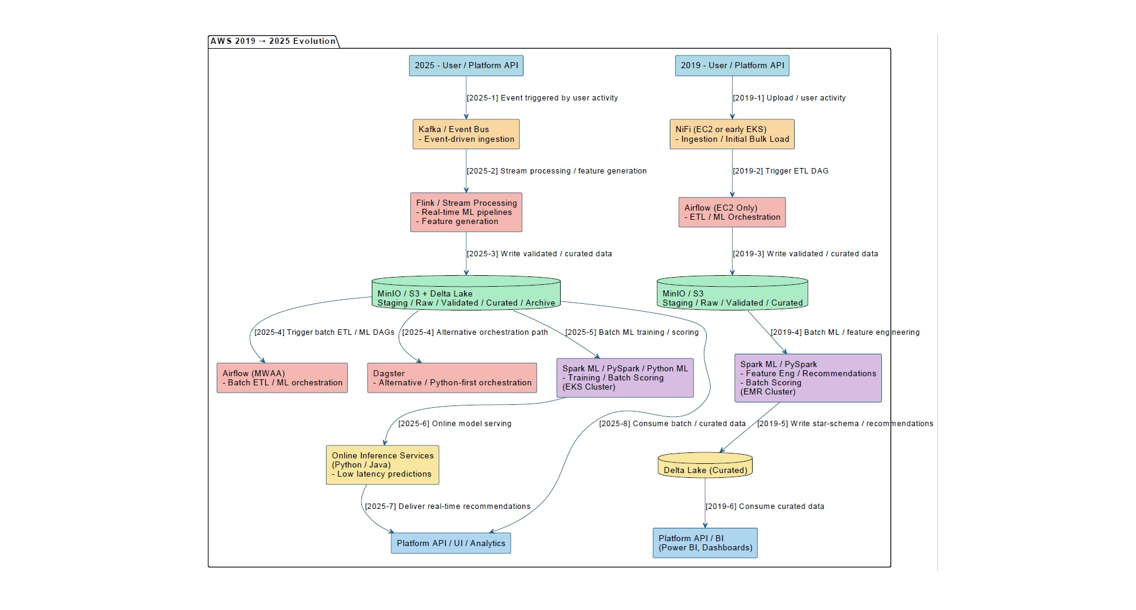

In the 2019 architecture, Apache NiFi handled both bulk and micro-batch ingestion while Spark on EMR performed batch and micro-batch analytics orchestrated via self-managed Airflow. By 2025, the platform evolves to a dual-ingestion approach: NiFi for initial bulk loads and Apache Flink for continuous streaming ingestion. Spark on EKS is retained for batch and ML workloads, with orchestration via MWAA or Dagster. This evolution enables clear separation of batch, streaming, and ML processing, optimizes scalability, and supports near real-time KPI generation via Power B.

Control Plan vs Data Plan diagram 2019 vs 2025: This version is architecturally expressive and excellent for senior reviewers, ADRs, and executives.
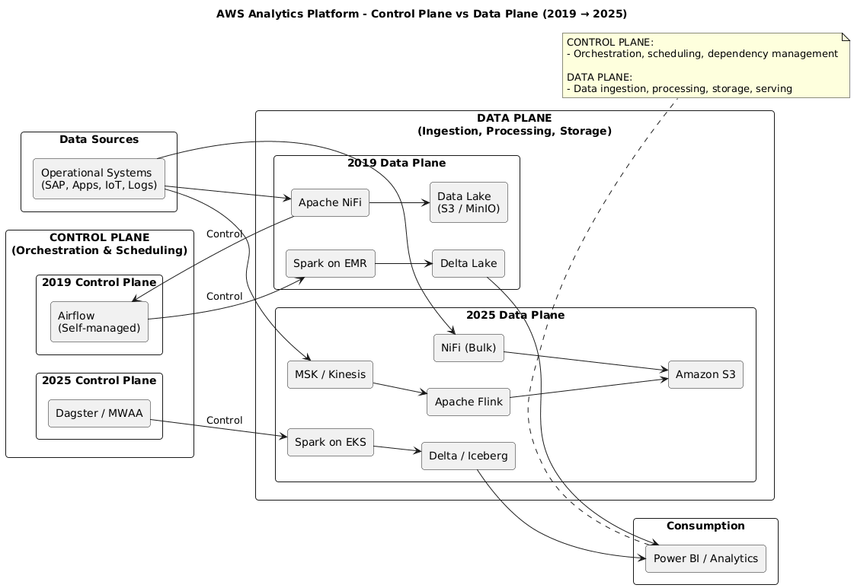
2019 Architecture – Bulk ingestion
- Airflow is the control plane
- Airflow:
  - Triggers NiFi (via REST)
  - Orchestrates Spark jobs
- NiFi is not autonomous
✔️ Airflow → NiFi → Spark

2019 Architecture – Continuous & micro-batch ingestion
- NiFi:
  - Listens to incoming data
  - Detects new files / events
  - Triggers Airflow DAGs when needed
- Airflow still orchestrates Spark
✔️ NiFi → Airflow → Spark
In the 2019 architecture, Apache NiFi was deployed on EC2 instances (or Kubernetes for on-prem or hybrid scenarios), aligned with the VM-centric operational model of the time.
- NiFi = ingestion (EC2 or Kubernetes for on-prem or hybrid deployment)
- Airflow = orchestration (control plane) / self managed on EC2 for Amazon deployment
- Spark = processing
- ❌ No broker → no event-driven semantics
- ✔ Matches how EMR + Airflow was actually used
2025 Architecture- – Continuous & micro-batch ingestion
In the 2025 target architecture, NiFi is containerized and deployed on Amazon EKS (or Kubernetes for on-prem or hybrid scenarios) alongside Apache Flink and Spark, enabling a fully cloud-native ingestion and processing platform with improved scalability, resiliency, and operational consistency.
- NiFi on Amazon EKS
- Kafka/Amazon MSK introduced for data-plane decoupling
- Flink/Amazon MSAF (Amazon Managed Service for Apache Flink) owns streaming + micro-batch
- Spark focuses on batch & ML
- Dagster or Amazon MWAA (Managed Workflow for Apache Airflow) improves orchestration semantics
The Evolution between 2019-2025 for Continuous & micro-batch ingestion
2019
- NiFi → Airflow → Spark (EMR)
2025
- NiFi (EKS) → S3 (bulk)
- MSK/Kinesis → Managed Flink → S3 (streaming)
- Dagster or MWAA (Managed Workflow Apache Airflow) → Spark on EKS (batch & ML)

In the 2025 target architecture, real-time streaming and micro-batch workloads are handled by Amazon Managed Service for Apache Flink, eliminating the need to operate Flink on Kubernetes. Batch analytics and ML pipelines are executed using Spark on Amazon EKS, while Apache NiFi is containerized and deployed on EKS for bulk ingestion and backfill scenarios.
The evolution from Spark micro-batching (2019) to managed Flink (2025) reflects a shift from time-based batch processing to event-time streaming, enabling near real-time analytics, online feature computation, and improved data freshness guarantees.
ML Features added in 2025
Initial ML implementations relied on batch-derived features embedded in ETL pipelines; later evolved toward explicit feature management to support real-time and scalable ML workloads. In 2019, ML features were produced as part of batch ETL pipelines and stored in curated datasets, without a dedicated feature store. Feature definitions were embedded in Spark jobs and reused by convention. By 2025, the architecture evolved to introduce explicit feature management capabilities to support real-time inference, feature reuse, and ML automation.
Feature Management Evolution (2019 → 2025)
In 2019, machine learning features were implicitly managed as part of batch data processing pipelines. Feature computation was embedded directly within Spark ETL jobs, producing engineered feature columns stored in curated datasets (Delta/Parquet). These features were primarily consumed during offline model training and analytics workloads. Feature definitions, versioning, and reuse were governed by convention and documentation, rather than by a dedicated platform capability. This approach was well suited for batch-oriented ML use cases but introduced limitations around feature reuse, consistency between training and inference, and real-time availability.
In 2019, the architecture did not include:
- A dedicated feature store (Feast Feature Store, SageMaker Feature Store, Databricks FS, etc.)
- Online/offline feature synchronization
- Feature versioning or discovery as first-class concepts
These capabilities were not mature or widely adopted at that time, especially in AWS-managed form.
In 2019, features existed implicitly, embedded inside:
Spark transformation outputs
- Aggregated datasets in Delta / Parquet
- Feature-like columns such as:
  - avg_session_duration_7d
  - content_completion_rate
  - error_rate_post_training

Batch-oriented feature preparation
- Features were:
  - Computed during ETL
  - Stored in curated (Gold) tables
  - Recomputed for each training job
Training-time only features
- Features used:
  - For offline model training
  - Not reused consistently for real-time inference
- Risk of training–serving skew existed
Important distinction: Features were data products, not managed assets
In 2019, features existed implicitly, embedded inside:
Spark transformation outputs
- Aggregated datasets in Delta / Parquet
- Feature-like columns such as:
  - avg_session_duration_7d
  - content_completion_rate
  - error_rate_post_training
Batch-oriented feature preparation
- Features were:
  - Computed during ETL
  - Stored in curated (Gold) tables
  - Recomputed for each training job
Training-time only features
- Features used:
  - For offline model training
  - Not reused consistently for real-time inference
- Risk of training–serving skew existed

What changed by 2025
By 2025, requirements could evolve:
- Real-time personalization
- Streaming ML features
- Online inference
- Multiple ML consumers
- Strong governance
This forced the introduction of:
- Explicit feature metadata
- Feature reuse
- Online + offline feature parity
- Automation
Hence the Feature Store appears in 2025, not in 2019

By 2025, the architecture evolved to support explicit feature management as a first-class capability. Feature generation was decoupled from core ETL pipelines and aligned with streaming and near real-time processing (Apache Flink) as well as batch processing (Spark on EKS). Feature metadata—including ownership, freshness, lineage, and usage—became centrally managed to ensure semantic consistency across ML pipelines.
This evolution enabled online and offline feature parity, reduced training–serving skew, and supported advanced use cases such as real-time personalization, recommendation systems, and predictive insights. The introduction of structured feature management significantly improves ML automation, scalability, and governance across the platform.

Feature Store – 2025 Architecture:
In the target architecture, a Feature Store is introduced as a first-class component to manage machine learning features across batch and streaming pipelines. Engineered features produced by Apache Flink (streaming) and Apache Spark on EKS (batch/ML) are registered with centralized feature metadata, ensuring semantic consistency, versioning, lineage, and freshness guarantees.
The Feature Store enables online feature serving for real-time inference.

Feature Store – 2025 Architecture Diagram:
The following diagram describes the 2025 feature store architecture within the data flow. It illustrates the 2019 architecture, which relied on a batch-oriented Feature Store, and the addition of a real-time Feature Store in 2025.

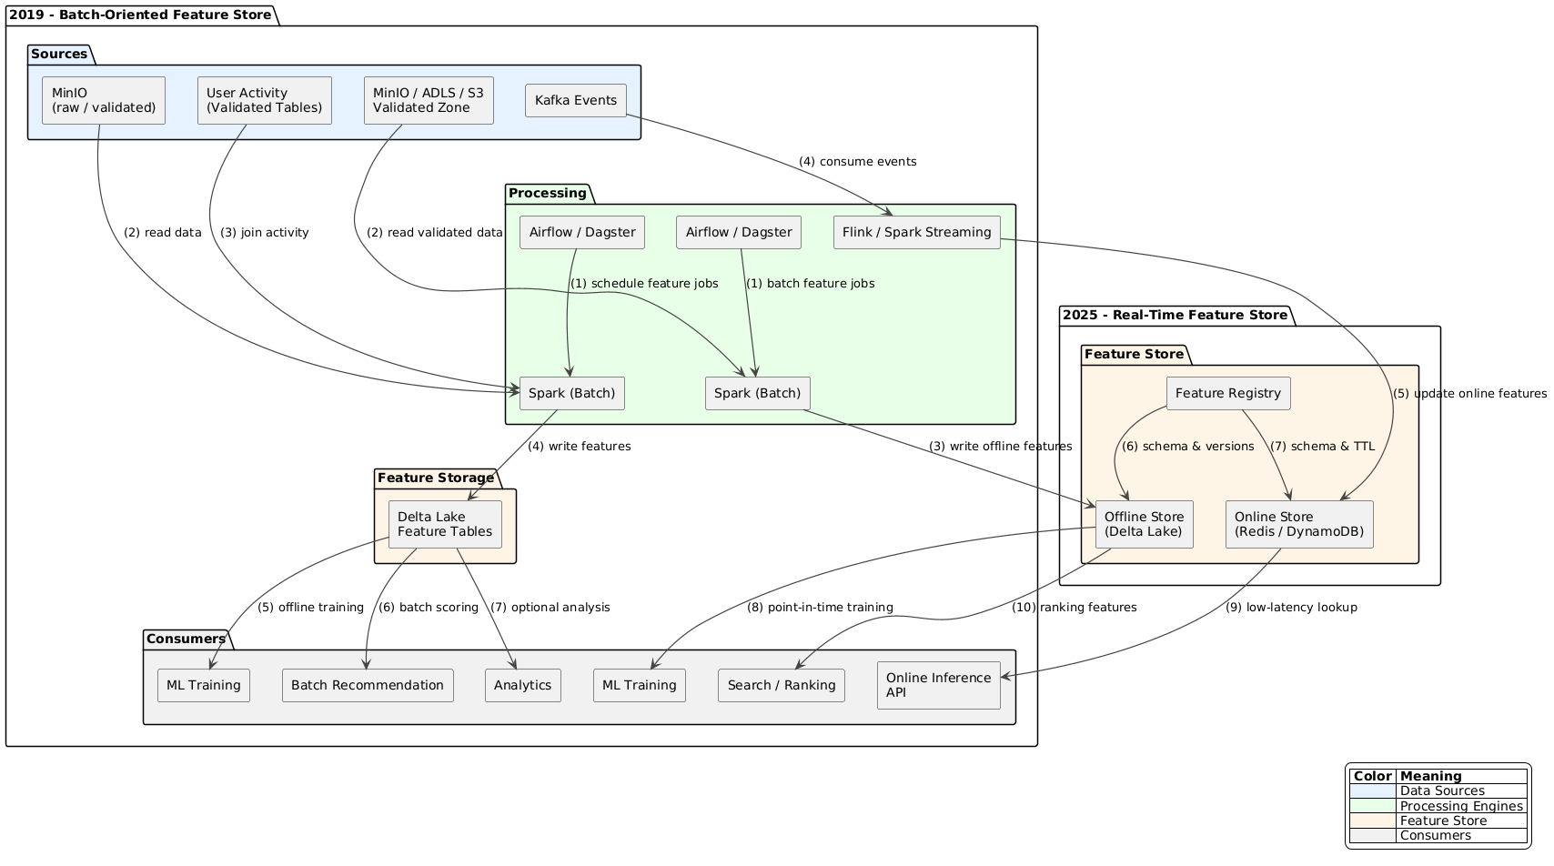

2025 Detailed Architecture Diagram
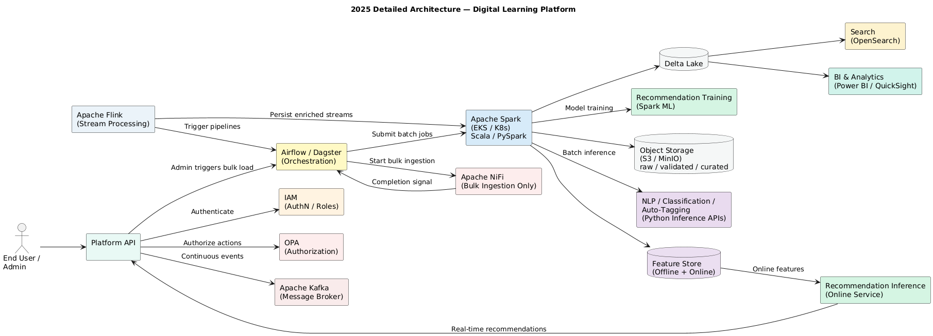
In 2019, ingestion relied on NiFi for both batch and continuous flows, with Spark handling batch analytics and ML. By 2025, continuous ingestion evolved to Kafka and Flink to support high-throughput, low-latency streams, while NiFi was retained for bulk ingestion. Spark remains the core batch and ML engine, but a feature store and real-time inference services were introduced to enable online recommendations.
Capability | 2019 | 2025
Bulk ingestion | NiFi | NiFi (unchanged)
Continuous ingestion | NiFi | Kafka + Flink
Orchestration | Airflow | Airflow / Dagster
Processing | Spark (batch + ML) | Spark (batch + ML)
Feature Store | ❌ | ✔ Introduced
Recommendation | Batch only | Training + Online inference

Continuous Ingestion Justification (Flink) — Next-Generation Platform
For the next-generation of the learning platform, the scope extends from field employees to office employees, covering a wide spectrum of learning materials: safety procedures, engineering reports, legal documents, multimedia content, and curated external resources.
Continuous ingestion must support:
- Daily additions from internal departments and curated external content.
- Sporadic bursts of large batches of material (e.g., engineering reports or multimedia files).
- Real-time updates of features used by ML microservices for classification, auto-tagging, and recommendation engines.
The need for near-real-time feature generation, exact processing semantics, and support for peak ingestion events makes Apache Flink the ideal choice. Flink seamlessly integrates with Kafka to consume events, enrich them, and feed both the Feature Store and ML inference services, enabling actionable, low-latency recommendations for all users.
By using Flink, the platform is future-proof: as more content and users are added, the system can scale without redesign, ensuring continuous ingestion remains reliable, consistent, and low-latency. NiFi remains in place for bulk ingestion during initial platform launches or major departmental content uploads.
How this process works
- Repository / Drop Folder:
  - A shared location (S3 bucket, MinIO folder, network drive) where content is uploaded.
  - Could be structured by department, category, or content type.
- Admin triggers continuous ingestion:
  - Instead of manually uploading each file or scheduling fixed daily batches, the admin selects a folder (or multiple folders) for ingestion.
  - The ingestion engine monitors the repository for new files or subfolders.
- Flink handles ingestion automatically:
  - Flink continuously watches the repository (or consumes events via Kafka that report new files).
  - Each new file triggers:
    - Validation / preprocessing
    - Feature extraction
    - ML enrichment (classification, auto-tagging)
    - Writing to validated / curated zones and Feature Store

- Advantages:
  - No need to guess or schedule daily batches
  - Can handle sporadic uploads of unknown volume
  - Supports incremental processing: only new files are processed
  - Scales naturally with future growth

Option | How it works | Notes
Flink + File/Event Watch | Flink job monitors repository or consumes Kafka events that indicate new files | Fully real-time, can handle spikes, incremental processing
Flink + Periodic Scan | Flink triggers a scan every N minutes for new files in the drop folder | Slightly higher latency (minutes), simpler to implement
Airflow / Dagster Trigger | Admin triggers DAG that scans folder and sends files to Flink | Useful if some validation or approval is needed before ingestion

Business workflow example
- Morning: Admin sets /new_uploads/Engineering as continuous ingestion folder.
- Flink starts monitoring folder or consumes Kafka events from the repository.
- Afternoon: Admin adds /new_uploads/Legal and /new_uploads/HR.
- Flink automatically processes the new files and updates Feature Store / ML pipelines.
- Users querying the platform see updated recommendations and searchable materials without waiting for daily batch jobs.
This is effectively a drop-folder-based continuous ingestion, which is much more flexible than fixed batch scheduling.
Platform Event Flow for 2025 Architecture
Case A — Bulk ingestion
- Admin triggers bulk load → Airflow/Dagster starts NiFi
- NiFi loads data to staging/raw zones
- Airflow/Dagster triggers Spark batch jobs to:
  - Transform data
  - Populate curated / validated zones
  - Run ML microservices for batch inference
  - Update Feature Store
Case B — Continuous ingestion
- Platform API / repository publishes new file/event → Kafka
- Flink consumes the Kafka events or monitors the repository.
  - Performs stream enrichment, basic validation, incremental feature computation.
  - Can directly write enriched events / features to the Feature Store for online usage.
  - Can optionally send batches or mini-batches to Spark if heavier transformations are needed.
- Airflow/Dagster can be triggered periodically or on-demand to run Spark DAGs that perform:
  - ML microservice batch inference
  - Feature store batch update
  - Recommendation engine model retraining
- ML microservices (classification, auto-tagging, NLP) can be invoked either:
  - Directly by Spark (batch)
  - Or by Flink streaming (real-time inference for online features)
Key difference for 2025:
- Continuous ingestion: Flink can directly feed Spark or FS, bypassing Airflow/Dagster for low-latency updates.
- Bulk ingestion: Always goes through Airflow/Dagster → Flink →Spark → ML → Feature Store.

2025 Architecture Evolution: ML Platform, Fined Grain Security & Governance
Governance and Security Evolution (2019 → 2025)
2019 Architecture — Implicit and Tool-Centric Governance
In the 2019 architecture, data governance and security were primarily enforced at the processing and infrastructure levels. Access control was largely managed through IAM permissions, Spark job configurations, and application-level logic. Metadata existed in multiple places, including application schemas, star-schema definitions, and embedded pipeline logic, without a centralized metadata authority.
Key characteristics of the 2019 governance model included:
- Coarse-grained access control (bucket-level or job-level)
- Governance embedded in ETL and application code
- Limited cross-engine consistency
- No unified dataset catalog
- No formal lineage or auditability across analytics and ML workloads
This approach was sufficient for a limited number of consumers and processing engines but did not scale to increased data sharing, regulatory requirements, or machine learning workloads.
2025 Architecture — Centralized, Fine-Grained Governance
The 2025 architecture introduces governance as a first-class, cross-cutting capability, decoupled from processing engines and application logic.
AWS Glue Data Catalog is introduced as a centralized metadata registry describing all curated and analytical datasets stored in the data lake, including Delta Lake tables used for analytics, feature engineering, and machine learning training. Glue serves as the authoritative reference for dataset definitions across all consuming engines.
AWS Lake Formation builds on top of the Glue Data Catalog to enforce fine-grained access control policies, including table-, column-, and row-level permissions, as well as dynamic data masking. These policies are applied consistently across Spark, Flink, Athena, and SageMaker, ensuring uniform security enforcement regardless of the execution engine.
Key improvements introduced in 2025 include:
- Centralized dataset discovery and metadata management
- Fine-grained, role-based access control across all engines
- Separation of governance concerns from ETL and application code
- Improved auditability and regulatory compliance
- Consistent governance across analytics and machine learning workloads
This evolution enables secure data sharing, supports multiple personas (data engineers, ML engineers, legal teams, field operations), and provides the foundation required for scalable machine learning and advanced analytics.
Aspect | 2019 | 2025
Metadata | Distributed, implicit | Centralized (Glue Data Catalog)
Access Control | Coarse-grained | Fine-grained (Lake Formation)
Governance Location | Embedded in jobs | Centralized policy layer
Cross-engine Consistency | Limited | Full
ML Readiness | Low | High
Auditability | Minimal | Strong

Key architectural points (important)
- Glue Data Catalog
  - Registers what datasets exist (Delta tables, curated datasets, training datasets)
  - Is the single metadata reference for all engines
- Lake Formation
  - Enforces who can access what
  - Applies fine-grained security consistently across:
    - Spark
    - Flink
    - Athena
    - SageMaker
- Nothing is duplicated
  - Data stays in Delta Lake
  - Glue = metadata only
  - Lake Formation = policy only

In the 2025 AWS-based architecture, AWS Glue Data Catalog is introduced as a centralized metadata registry for curated and analytical datasets stored in the data lake, including Delta Lake tables used for analytics and machine learning. AWS Lake Formation builds on top of the Glue Data Catalog to enforce fine-grained access control and governance policies across all consuming engines (Spark, Flink, Athena, and SageMaker), without replacing existing ETL pipelines, feature stores, or domain-specific metadata.
Data Access conceptual governance flow
S3 / Delta Lake
↓
Glue Data Catalog (WHAT exists)
↓
Lake Formation (WHO can access)
↓
Spark / Flink / Athena / SageMaker
↓
Feature Store / BI / ML APIs
Why Glue Data Catalog & Lake Formation should exist in our 2025 AWS architecture
- Our platform already works without Glue and Lake Formation
- They are introduced to add:
  - Centralized metadata governance
  - Fine-grained security
  - Cross-engine consistency (Spark, Flink, Athena, SageMaker)
  - Auditability
Roles:
- Glue Data Catalog = centralized technical metadata registry
- Lake Formation = centralized access control & governance layer
In our architecture, what gets registered in Glue: Tables that SHOULD be in Glue Data Catalog
These are data lake–level datasets, shared across engines:
- Curated Delta Lake tables
  - Example: s3://hq-data/curated/documents_enriched/
  - Registered as
    - database: curated
    - table: documents_enriched
    - format: delta
Glue stores: Schema, Location, Format, Partitions
- Analytical / star-schema tables
  - Examples: fact_documents, dim_assets, dim_sites
Registered so that: Athena, BI tools, ML pipelines & Auditors all see the same definition.
- Training datasets (important for ML Platform like Amazon SageMaker)
  - Example: curated.training_nlp_v3
This allows: SageMaker training jobs Governance, Reproducibility & Lineage
Data Relationship Summary
Component | Role
Delta Lake | Stores data
Glue Data Catalog | Describes data
Lake Formation | Secures data
Feature Store | Serves ML features
MinIO | Object storage
Star Schema | Analytics model
SageMaker | ML execution
Below architecture diagram’s describes the addition of governance layer through Amazons Glue Data Catalog & Lake Formation.
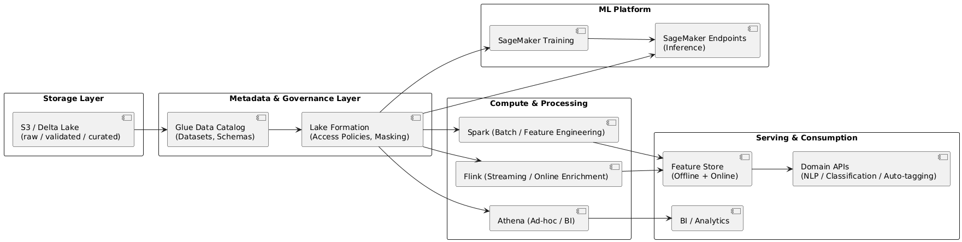
Next four sections cover briefly security, governance, ADR (architecture decision record) & details of integration of ML Platform (Amazon SageMaker) to our architecture.

1. Add Security / IAM layers (Amazon): Key security principles
Across 2019 → 2025, what changed is not security existence, but security granularity.
Core principles
- Identity-first access (IAM over network trust)
- Least privilege
- Separation of duties
- Data + ML artifacts secured independently
Security & IAM (2025 focus) – Amazon deployment scenario
Security layers
- IAM Roles
  - Spark jobs (IRSA)
    - IRSA: In Amazon EKS for Spark jobs, IRSA (IAM Roles for Service Accounts) is a security feature that lets Kubernetes Service Accounts (SAs) directly assume specific AWS IAM roles, granting fine-grained access to AWS services (like S3, DynamoDB) without embedding AWS credentials in pods or using node IAM roles. It provides secure, temporary credentials, following the principle of least privilege by linking a pod's SA to an IAM role via OIDC, making Spark apps more secure & manageable on EKS
  - SageMaker training
  - SageMaker endpoints
- Lake access
  - S3 bucket policies
  - Table / column permissions via Glue + Lake Formation
- Online Feature Store
  - DynamoDB IAM policies
  - Redis in VPC (SG + IAM auth if supported)
- Network
  - Private VPC endpoints
  - No public S3 / SageMaker access
- Secrets
  - AWS Secrets Manager
- Audit
  - CloudTrail
  - Model access logs
2. Governance & Lineage — what changed from 2019 to 2025
2019 reality
- Metadata existed
- Governance was table-centric
- No ML lineage
- No feature visibility
2025 reality
- Governance expands to four artifact types: Both Amazon or Azure deployments
Artifact | Governed by
Data tables | Glue / Purview
Features | Feature Store + metadata
Models | Amazon SageMaker
Endpoints | ML platform
Key additions
  - Column-level security
  - Feature lineage (source → feature → model → endpoint)
  - Impact analysis (drop a feature → which models break?)
Conceptual Governance Flow
Raw Data
↓
Curated Tables
↓
Feature Definitions
↓
Feature Store
↓
Model Training
↓
Model Registry
↓
Online Endpoint
Governance follows the ML lifecycle, not just data ingestion.
3. Final Architecture Decision Record (ADR)
Below is a clean, reusable ADR we can paste directly into our architecture repository.

ADR-: Adoption of Feature Store–Centric ML Platform based Architecture (2019 → 2025)
Context: The 2019 analytics and ML platform relied on:
- Curated Delta Lake fact tables
- Spark batch jobs for feature engineering (feature extraction / feature concept is implicit) & recommendations
- Custom REST-based ML microservices (NLP, classification, auto-tagging)
- Limited ML governance and no online inference parity
As ML usage evolved toward:
- Real-time recommendations
- Online inference with SLAs
- Feature reuse across models
- Increased regulatory & audit requirements
The existing architecture no longer provided sufficient correctness, reproducibility, or operational guarantees.
Decision
- We adopt a Feature Store–centric ML architecture with:
- Offline Feature Store implemented on Delta Lake
- Online Feature Store implemented on low-latency key-value storage
- AWS: DynamoDB / Redis
- Managed ML platforms as control planes
- AWS SageMaker
- Identity-first security
- AWS IAM + IRSA
- Centralized governance & lineage
- AWS Glue + Lake Formation
Facts
- Delta Lake already provided strong offline guarantees (ACID, time travel) but could not meet online inference latency requirements.
- Feature Stores formalize features as versioned, governed ML contracts, not BI artifacts.
- Managed ML platforms provide standardized training, deployment, & monitoring pipelines.
- Identity-centric security aligns with least-privilege & zero-trust principles.
- Governance tools extend lineage beyond data tables to features, models, and endpoints.
Consequences:
Positive
  - Training/serving parity enforced
  - Reduced feature duplication
  - Improved auditability & compliance
  - Scalable real-time inference
  - Clear separation of responsibilities
Trade-offs
- Increased platform complexity
- Additional operational components (online store, registries)
- Stronger dependency on cloud-native services
Alternative Considered
Option | Reason Rejected
Delta-only Feature Store | Cannot meet online latency SLAs
Cache on top of Delta | Complex invalidation, no guarantees
Pure custom ML services | Poor governance & scalability
Hadoop/YARN-centric ML | Misaligned with cloud-native ML
Decision Outcome
This architecture supports both:
- 2019 batch-oriented workloads
- 2025 real-time, feature-driven ML use cases
& provides a sustainable foundation for future ML expansion.
The evolution from 2019 to 2025 is not a storage upgrade — it is a shift from data-centric analytics to feature-centric, governed, identity-secured ML platforms.

Executive Summary — ML Platform Evolution (2019 → 2025)
Why the Architecture Evolved
2019 reality
- Data platforms optimized for analytics & batch ML
- Features embedded implicitly in Delta fact tables
- ML models deployed as custom REST services
- Limited governance, no online inference parity
2025 reality
- ML systems are production systems with SLAs
- Real-time inference & personalization are mainstream
- Features must be reusable, versioned, auditable contracts (the adoption on of ML platform such as Amazon SageMaker or Azure ML for cloud or hybrid deployment scenarios)
- Strong regulatory, security, & operational requirements

What Changed Architecturally
From:
- Data-centric pipelines
- Batch-first Spark ML
- Cluster-based security
- Table-level governance
To:
- Feature-centric ML platforms
- Offline + Online Feature Store
- Managed ML control planes (Amazon SageMaker)
- Identity-first security & end-to-end lineage

4. ML Platform Architecture Handout — 2019 → 2025 Evolution
Purpose: Provide a clear, business-aligned overview of how the ML platform evolved from batch, data-centric analytics (2019) to a feature-centric, governed, real-time ML platform (2025) on AWS and Azure.
2019 Baseline Architecture (Data-Centric)
Core characteristics
- Lakehouse built on Delta Lake
- Spark batch jobs for feature engineering and recommendations
- Custom REST ML microservices:
  - NLP
  - Classification
  - Auto-tagging
- ML primarily offline (training & batch scoring)
- Governance limited to tables, not ML artifacts
Limitations
- Features implicit (columns in fact tables)
- No training/serving parity
- Limited reuse across models
- No low-latency inference guarantees
2025 Target Architecture (Feature-Centric)
Core characteristics
- Features treated as first-class ML contracts
- Offline + Online Feature Store split
- Managed ML platforms act as ML control planes
- End-to-end lineage model lineage
- Supports real-time inference with SLA
Cloud Deployment Mapping (considering both Amazon & Azure choices)
Capability | Amazon | Azure
Lakehouse | S3 + Delta | ADLS + Delta
Feature Engineering | Spark on EKS | Databricks / Spark on AKS
Offline Feature Store | Delta Lake | Delta Lake
Online Feature Store | DynamoDB / Redis | Redis / Cosmos DB
ML Control Plane | SageMaker | Azure ML
Governance | Glue + Lake Formation | Microsoft Purview
Identity & Security | IAM + IRSA | Azure AD + Managed Identity
Security & Governance Model
Security
  - Identity-based access (IAM)
  - Least privilege for:
- Data
- Features
- Models
- Endpoints
- Private networking & secret management
Governance
- Table, column, feature, and model lineage
- Feature → Model → Endpoint traceability
- Audit-ready architecture
Why Feature Store Was Not Present in 2019: Storage and compute capabilities already existed. Missing elements were
- ML operational maturity
- Online inference requirements
- Feature ownership & governance
Feature Store became necessary only when
- Models moved to production
- Predictions required SLAs
- Feature reuse became critical
Business Outcomes
- Consistent training & inference behavior
- Faster delivery of ML use cases
- Reduced feature duplication and errors
- Improved compliance and auditability
- Scalable real-time personalization & recommendations
This evolution is not a tooling upgrade, it is a shift from data-centric analytics to feature-centric, governed, production ML platforms. The 2025 architecture supports both legacy batch ML & modern real-time AI, providing a sustainable foundation for future growth.
2019 recap (what we had): In 2019, our architecture was Spark-centric:
  - Spark batch jobs did everything
- Feature engineering
- NLP (NLP pipeline)
- Classification
- Auto-tagging
- Recommendation engine
- Outputs were written to Delta fact tables
- REST APIs (used by our Microservices serving NLP pipeline) were often:
- Thin wrappers
- Or even absent (batch consumption)
This worked because
- Inference was mostly offline
- Latency was not a business constraint
- Models were not continuously retrained
2025 core principle (this is the key shift)
- Spark is no longer the inference runtime.
- Spark remains the feature & training engine.
In 2025
- Spark = data processing & model training
- SageMaker / Azure ML = model lifecycle & inference
This is the most important mental model change.

What SageMaker as an ML Platform could actually replace (& what it does NOT)
An ML Platform (such as SageMaker) replaces
Capability | Before (2019) | After (2025)
Model training orchestration | Spark jobs | SageMaker training jobs
Model registry | Ad-hoc / none | SageMaker Model Registry
Online inference runtime | Spark batch | Managed endpoints
Scaling inference | Manual | Auto-scaling endpoints
A/B testing, versions | Manual | Native
SageMaker does not replace
Item | Why
Feature engineering | Still Spark’s job
Business logic | Still needed
Application APIs | Still needed
Event-driven logic | Still needed
Some batch ML jobs | Still needed
What happens to our 3 ML REST microservices?
Important distinction
We had two things mixed in 2019:
- Model inference
- Service orchestration / business logic
In 2025, these are explicitly separated.
2025 pattern for NLP / Classification / Auto-Tagging REST Microservices
Before (2019)
Spark Job
├ Feature extraction
├ Model inference
├ Business rules
└- Write results
After (2025)
API / Service
├ Fetch features (online store)
├ Call SageMaker endpoint: ml computing happens at this level
├ Apply business rules
└- Return response
The REST services (NLP / Classification / Auto-Tagging) still exist, but:
- They are lighter
- They do not run Spark
- They do not host models
- They orchestrate inference, not compute it.
What about the Recommendation Engine? This one is nuanced.
Option A — Offline recommendations (still Spark)
If recommendations are:
- Nightly / hourly
- Large-scale batch
- Written to tables
Spark batch jobs remain valid
Option B — Online / real-time recommendations (2025 target)
If recommendations are:
- User-driven
- Context-aware
- Low-latency
Flow becomes
Client
→ Recommendation API
→ Online Feature Store
→ SageMaker endpoint
→ Ranked recommendations
Spark is no longer in the request path.

So, do we still need the recommendation engine? Yes, but its form changes.
2019 | 2025
Spark job | Trained model
Embedded logic | Encapsulated model
Batch output | Endpoint response
Table-based | Feature-based
We no longer maintain:
- Spark inference logic
- Spark serving clusters
We still maintain:
- Recommendation models
- Recommendation APIs
- Recommendation features
And SageMaker becomes our ML execution plane.
We still need:
- APIs (for NLP, classification, tagging, recommendations)
- Event pipelines
- Feature pipelines
- Governance & security layers
What disappears is:
- Spark as a serving engine
- Custom inference infrastructure
SageMaker does not eliminate our microservices or recommendation engine. It eliminates Spark-based inference and replaces it with managed model endpoints.
What stays on Spark vs moves to ML endpoints (decision table)
Keep on Spark (even on 2025)
Workload | Why
Feature engineering | Heavy data transforms
Offline training | Large datasets
Batch scoring | Cost-efficient
Historical backfills | Deterministic replay
Recommendation pre-compute | When latency is not required
Move to ML endpoints (SageMaker / Azure ML)
Workload | Why
NLP inference | Tokenization + low latency
Classification | Stateless, request-based
Auto-tagging | Online usage
Real-time recommendations | SLA-driven
Model experimentation | Versioned endpoints
Spark is not suitable for online inference

Spark
- Feature engineering
- Offline training
Kafka + Flink
- Feature freshness
- Stream aggregation
- Feature materialization
SageMaker
- Model training orchestration
- Model registry
- Online inference endpoints
Flink feeds features, not predictions.

2025 maturity means Spark for data, Flink for streams, and SageMaker for inference.
And NLP / Classification / Auto-Tagging REST Microservices are not model training they are model inference services.
Clear separation: Training vs Inference
Model training: What it is
- Learning model parameters (weights)
- Computationally heavy
- Runs on historical datasets
- Not latency-sensitive
Typical characteristics
- Batch
- Hours or minutes
- Produces a model artifact
Runs on
- Spark (distributed training / feature prep)
- SageMaker Training Jobs (for Amazon cloud deployment) or Azure ML training pipelines (for Azure cloud deployment)
Model inference: What it is
- Applying an already-trained model
- Stateless or lightly stateful
- Latency-sensitive (often)
Typical characteristics
- Online (ms–100 ms)
- Or batch scoring
- Produces predictions
Runs on
- REST services
- SageMaker endpoints (for Amazon cloud deployment) ore Azure ML endpoints (for Azure cloud deployment)
(Historically) Spark jobs — but this is no longer recommended
Where NLP / Classification / Auto-Tagging fit. What these services actually are
Service | What it does | Category
NLP service | Text → embeddings / labels | Inference
Classification service | Feature vector → class | Inference
Auto-tagging | Content → tags | Inference

These services:
- Consume a trained model
- Do not update weights
- Do not learn
- Return predictions
They are inference services, not training.
In 2019, training & inference were collapsed into Spark jobs:
Spark Job
├ Feature extraction
├ Model training (sometimes)
├ Model inference
└─ Write results
So conceptually:
- We ran a Spark job
- We got predictions
It felt like “the service is training”
But architecturally, these were different phases happening in the same runtime.
How this maps in 2025
Training Pipeline
Delta Lake
→ Spark (feature engineering)
→ SageMaker Training Job
→ Model Artifact
→ Model Registry
Inference Pipeline
Client / Event
→ NLP / Classification / Auto-Tagging API
→ Online Feature Store
→ SageMaker Endpoint
→ Prediction
The service:
- Does not train
- Does not store models
- Does not scale ML infrastructure
- Only orchestrates inference
Even if the same team owns both:
- Training runs in pipelines
- Inference runs in services
They are never the same thing in a mature architecture.
In 2019 we trained models — but training was embedded inside Spark batch jobs, not treated as a first-class lifecycle. There was no “training platform”, no registry, and no separation between:
- feature engineering
- training
- inference
They all lived in the same execution context.
What “training” looked like in your 2019 architecture
Typical 2019 Spark job pattern
Spark Job (NLP / Classification / Recommendation)
├ Read historical data (Delta)
├ Feature extraction
├ Fit model (Spark ML / MLlib / custom Python)
├ Apply model to same data
└─ Write predictions back to Delta
Key observations:
- fit() was called → that is training
Models were often: transient, overwritten & not versioned
Inference happened immediately after training. Outputs were stored, not models
Which of our 2019 workloads involved training
Based on our description:
Recommendation engine (Spark ML)
- Definitely trained
- Collaborative filtering / ranking models
- Trained on historical interactions
- Batch-scored
NLP service
- If using:
- TF-IDF
- Word2Vec
- Topic models
→ Training occurred
Classification
- Logistic regression / tree / SVM (Support Vector Machine)
→ Training occurred
Auto-tagging
- If rule-based → ❌ no training
- If ML-based → ✔ yes training
Rule-based auto-tagging applies predefined logic and does not require training, whereas ML-based auto-tagging learns tagging patterns from historical data and therefore requires an explicit model training and lifecycle pipeline.
In most enterprise setups, at least 3 of the 4 involved training. Why it didn’t feel like “model training”
Because in 2019:
Missing Element | Impact
Model registry | Models invisible
Training pipelines | No explicit lifecycle
Versioning | Overwrites
Validation gates | Ad-hoc
Deployment step | None
So:
- We ran a Spark job
- We got results
- We moved on
Training was just “part of the job”.
The critical 2019 limitation (architectural): Training was a side-effect, not an intentional artifact. This caused:
- No reproducibility
- No rollback
- No auditability
- No training/serving parity
Which directly led to:
- Feature Stores in 2025
- Managed ML platforms
- Explicit separation of phases
How the same workload looks in 2025 (contrast)
2019
Spark job → predictions
2025
Spark → features
SageMaker → train model (happens as scheduled jobs periodically)
Registry → version
Endpoint → inference
We trained models in 2019, but we did not manage training — Spark did it implicitly for us. In our 2025 architecture without SageMaker, model training was still part of Spark jobs used by our microservices & recommendation engine. That architecture functionally worked, but it was architecturally transitional, not fully mature.
What actually happened in Our 2025 (Flink + Spark, without SageMaker)
Our architecture likely looked like this without the addition of an ML platform such as Amazon SageMaker for the model training lifecycle:
Offline / Batch side
- Spark jobs did:
- Feature engineering
- Model training (fit())
- Batch scoring
- Models were:
- Generated inside Spark
- Stored in object storage
- Overwritten or manually versioned
Online / Near-real-time side
- Kafka + Flink
- Streaming feature aggregation
- Online feature materialization
Microservices
- Called Spark outputs or Flink results
- Did not manage model lifecycle
Training still lived inside Spark jobs, exactly like 2019. In our 2025 architecture without SageMaker, model training is still part of Spark jobs used by our microservices and recommendation engine.
The difference vs 2019 was streaming features, not ML lifecycle maturity.
Aspect | Status
Training location | Spark jobs
Inference location | Spark / Flink
Model registry | ❌
Version promotion | ❌
Training–serving parity | Weak
Rollback | Manual
This means:
- Models were side-effects
- Features were tables, not contracts
- ML governance remained implicit
What SageMaker (as an ML Platform) changes
SageMaker removes training from Spark’s responsibility. With SageMaker (or Azure ML)
Spark
→ Feature Engineering ONLY
SageMaker
→ Training
→ Model Registry
→ Versioning
→ Deployment
Endpoints
→ Inference

Spark no longer:
- Trains models
- Owns model artifacts
- Serves predictions
This is the architectural maturity leap.
Our 2025 Flink-based architecture without SageMaker still trained models inside Spark jobs — just like 2019 — and SageMaker’s role is to extract training and inference from Spark into a managed ML lifecycle. SageMaker does not replace our NLP, Classification, Auto-Tagging REST microservices, nor our recommendation engine.
What SageMaker replaces is where models are trained & executed, not the services themselves.

In 2019 and in our 2025 (no-SageMaker) architecture:
Spark jobs contained everything:
- Feature logic
- Training logic
- Inference logic
- Business orchestration
So it felt like:
- “The microservice is the ML system”
In 2025 with SageMaker:
- ML is extracted from those services
- Services become orchestrators, not ML runtimes

What SageMaker actually replaces. It replaces Spark-based ML execution

Before | After
Spark job trains model | SageMaker training job
Spark job runs inference | SageMaker endpoint
Spark cluster scales ML | Managed scaling
Manual versioning | Model Registry
Spark is no longer an ML runtime.

2025 “Before vs After” — exact comparison
Before (Spark / Flink inference)
NLP Service
└─ Spark job
├ Feature extraction
├ Model inference
└─ Response
After (SageMaker inference)
NLP Service
├ Fetch features (online store)
├ Call SageMaker endpoint
├ Apply business rules
└─ Response
SageMaker becomes our ML execution & lifecycle layer.
Our services:
- Own API contracts
- Own orchestration
- Own business logic
SageMaker:
- Owns models
- Owns training
- Owns inference execution
SageMaker replaces Spark-based training and inference inside our ML services.
What we used to do (before SageMaker)
Inside your NLP / Classification / Recommendation code (Spark or service):
- Load model artifacts from storage
- Manage model version paths
- Keep model in memory
- Handle concurrency
- Scale workers
- Restart on failure
- Redeploy on new model
- Roll back manually
All of that logic was implicitly our responsibility. What SageMaker endpoint is doing instead
A SageMaker endpoint:
- Hosts one specific model version
- Exposes a stable HTTPS endpoint
- Scales automatically
- Handles concurrency & retries
Supports:
- Canary / A-B testing
- Rollback
- Monitoring
We did not lose logic — we externalized infrastructure & introduce the model training lifecycle pattern (initiating model training sessions periodically within Amazon SageMaker).
Before SageMaker, our stack looked like:
NLP Service
├Load model from S3
├ Deserialize model
├ Run inference
├ Manage memory & threads
└─ Return result
SageMaker makes the model processing explicit and standardized.
Moves to SageMaker
- Model loading
- Model execution
- Runtime scaling
- Model version binding
- Inference infrastructure
Does NOT move
- Feature logic
- Business rules
- API contracts
- Domain logic
We do “Apply business rules: same code as before” but the ML part of it would be executed inside SageMaker as a packaged docker container exposing an endpoint interface through http or gRPC protocols to be called by our Microservices for ML computing jobs. SageMaker sits between feature fetch and business rules
SageMaker replaces the model execution & lifecycle we previously embedded inside our services, while our business rules & APIs remain exactly the same. “In 2025, our NLP or other microservices no longer runs ML code — it orchestrates features, inference, and business rules.” They orchestrate requests, features, & decisions; SageMaker owns training & prediction execution.
Microservice handles:
- Input validation
- Feature orchestration
- Business rules
- -Response formatting
SageMaker handles:
- Loading model into memory (coded & packaged as a docker container by us but managed by SageMaker at runtime)
- Executing ML math / inference (executing our own code which now leaves outside of our microservice & packaged as container exposing an endpoint interface)
- Auto-scaling & runtime management
- Model versioning / lifecycle
This makes responsibilities mutually exclusive and clear.
Observations: Without SageMaker, our service did everything ML-related, which:
- Coupled business logic & ML runtime
- Made scaling, rollback, & versioning harder
With SageMaker, our service:
- Only orchestrates
- Leaves ML math, scaling, & lifecycle management to a managed service
Can focus on business rules and orchestration
Example: What happened to our 2019 NLP pipeline with SageMaker?
Our 2019 NLP pipeline:
- Tokenization
- Lemmatization
- Embeddings:
- TF-IDF or
- Word2Vec or
- BERT
- NER
- Classification
- Auto-tagging

These are ML logic, not business logic. They are:
- Feature engineering
- Representation learning
- Model inference logic
They never disappear in 2025. They move location. Where do those steps live in 2025 with SageMaker:
Before (2019)
NLP Microservice
├Tokenization
├ Lemmatization
├ Embeddings (TF-IDF / Word2Vec / BERT)
├ NER
├ Classification, Auto-Tagging
└─ Business rules
After (2015 with Amazon SageMaker)
NLP Microservice
├─Fetch features
├ Call SageMaker endpoint
└─ Business rules
SageMaker NLP Model (nlp-model-v3)
├ Tokenization
├ Lemmatization
├ Embeddings (TF-IDF / Word2Vec / BERT)
├ NER
└─ Prediction
nlp-model-v3 contains our own machine learning code (packaged as a container) & being executed by SageMaker managed service runtime. All NLP pipeline steps now live inside the model artifact deployed in SageMaker.
So, what exactly is inside nlp-model-v3? nlp-model-v3 typically contains our preprocessing code
- Tokenizer
- Lemmatizer
- Text normalization
Our embedding logic
- TF-IDF vectorizer or
- Word2Vec model or
- BERT encoder (very common in 2023–2025)
Our trained model
- NER model
- Classification head
- Tagging model
Inference wrapper
- Code that accepts JSON
- Runs preprocessing + model
- Returns predictions
Model version
- v1, v2, v3 = different training data, embeddings, or architectures
Who decides TF-IDF vs Word2Vec vs BERT? We do — at training time. Not at inference time.
Important distinction
SageMaker does NOT decide:
- Which embedding algorithm to use
- Which NLP pipeline to apply
We decide:
- During model development & training
- When building the model artifact
Example decisions we make before deployment
- NLP approach:
- TF-IDF + Logistic Regression (classic)
- Word2Vec + CNN
- BERT fine-tuned for NER & classification
- We train the model accordingly
- We package it
- We deploy it as nlp-model-v3
At inference time, SageMaker just executes what we trained. SageMaker is responsible for:
- Running our container
- Scaling it
- Exposing it as an endpoint
- Versioning & monitoring
The model container (designed & coded by us) is responsible for:
- TF-IDF vs Word2Vec vs BERT
- Tokenization strategy
- NER architecture
SageMaker is a managed runtime for our ML pipelines.
In the 2025 architecture, NLP, Classification, Auto-Tagging, and Recommendation ML pipelines (tokenization, embeddings, NER, and prediction) are encapsulated within versioned SageMaker model artifacts. Application microservices no longer execute ML logic directly; instead, they orchestrate feature retrieval, invoke SageMaker inference endpoints, and apply domain-specific business rules.
nlp-model-v3 (our own code)
├ inference.py / inference.java
├ tokenizer logic
├ lemmatizer
├ embedding model (TF-IDF / Word2Vec / BERT)
├ trained weights
├ model config
└─ entrypoint handler
Packaged as:
- Docker container (most common)
- Or SageMaker prebuilt container + our code
- Model artifacts stored in S3
- Deployed as a scalable endpoint
SageMaker 2025 mindset
NLP Microservice
├ build feature payload
├ call SageMaker endpoint (HTTP)
└─ apply business rules
SageMaker Container
├ load NLP model
├ run NLP pipeline
└─ return prediction
The nlp-model-v3 artifact encapsulates our custom NLP pipeline implementation (tokenization, embeddings, NER, and inference logic) and is packaged as a SageMaker model packaged as a container. This container is deployed & executed in a managed SageMaker runtime environment, independent from application microservices, which invoke it remotely for inference.”
What belongs to SageMaker (ML responsibility)
SageMaker is responsible for everything related to the model itself.
1. Model training
- Consume historical, labeled data
- Learn model parameters
- Produce a trained model artifact
- Register and version the model
2. Model hosting
- Load the trained model into memory
- Bind a specific model version to an endpoint
- Expose a stable inference endpoint
- Handle concurrency, retries, scaling, and failures
3. Model inference
- Accept feature inputs
- Execute the mathematical prediction
- Return raw prediction results (scores, probabilities, embeddings)
Important: SageMaker has no knowledge of business rules, users, tenants, policies, or workflows.
What belongs to our microservices (business responsibility): NLP, Classification, Auto-tagging
The NLP service is an orchestration and decision layer, not an ML runtime.
Step 1 — Request handling
- Receive (e.g. an NLP) request from an application or upstream system
- Validate input format and required fields
- Apply basic request-level controls (size, language, tenant)
Step 2 — Feature retrieval
- Identify which features are required for this model
- Fetch online features (for real-time requests) from the feature store
- Optionally fetch offline features (for batch or asynchronous workflows)
Step 3 — Invoke the SageMaker endpoint
- Send the prepared feature payload to the correct model endpoint
- Do not load or execute the model
- Treat the endpoint as an external ML dependency
- Receive raw prediction outputs
This is the exact point where ML computation happens — outside our service.
Step 4 — Apply business rules
- Interpret prediction results
- Apply confidence thresholds
- Enforce domain policies (e.g., tenant rules, compliance rules)
- Combine predictions with non-ML logic
- Decide final outcomes
This logic is unchanged compared to your 2019 or 2025 (no SageMaker) architecture.
Step 5 — Response construction
- Build a domain-friendly response
- Mask or enrich results as needed
- Return the response to the caller
- Optionally emit events or logs
The Microservices orchestrates requests, features, and decisions; SageMaker owns training and prediction execution.
Offline vs Online clarification
Online inference
- NLP service fetches online features
- Calls SageMaker endpoint
- Applies business rules
- Returns response immediately
Offline / batch inference
- Spark prepares feature datasets
- SageMaker runs batch inference or
- Spark performs batch inference using a registered model
- Business rules are applied downstream
SageMaker is optional for offline inference, but preferred for online inference.
Role of SageMaker in 2025 Architecture
- SageMaker takes over all ML responsibilities:
  - Model training
  - Model versioning & registry
  - Model hosting & scaling
  - Online inference execution
Microservice Responsibility Changes
Microservice | Pre-2025 (Spark embedded) | 2025 (with SageMaker) / ML Responsibilities
NLP Service | Load model, run inference, manage memory/scaling, apply business rules | Only orchestrate: fetch features, call SageMaker endpoint, apply business rules
Classification Service | Same | Same pattern as NLP Service
Auto-Tagging Service | Same | Same pattern
Recommendation Engine | Spark batch: train + inference | Microservice orchestrates features, calls SageMaker endpoint for inference
Clear boundaries between ML responsibility and business responsibility
Key Benefits of SageMaker Introduction
- Scalable inference without increasing microservice complexity
- Model versioning and rollback for safety
- Decouples ML computation from business logic
- Improves operational reliability and observability
NLP, Classification, and Auto-Tagging services are inference pipelines responsible for applying trained models to incoming data streams (online or batch) in order to enrich datasets and persist predictions to Delta Lake. Model training and evolution are decoupled and executed independently via SageMaker training workflows.”
Training pipelines (SageMaker ML Platform Responsibility):
- Use large historical datasets
- Run periodically
- Produce new model versions
- Write:
  - Model artifacts
  - Metrics
  - Metadata
Training flow
Delta Lake (historical data)
↓
SageMaker Training Job
↓
Model artifacts (S3)
↓
Model Registry
Inference pipelines:
- Use trained models
- Process new data
- Write:
  - Predictions
  - Enriched data
  - Features
These are different lifecycles, different SLAs, and different failure modes.
Mental model:
Ingestion pipeline: “Apply knowledge”
Training pipeline: “Create knowledge”
They may use the same infrastructure, but they are not the same pipeline. Training pipelines are often:
- Periodic
- Background
- Triggered by humans or governance
They’re usually drawn as side pipeline.
Document ingestion and enrichment pipelines apply trained models to data, while model training is a separate, intentional process that periodically consumes historical curated data to produce new model versions
Typical 2019 pattern model training:
Developer trains model locally / in a notebook
↓
Exports artifacts (vectors, weights, vocabularies)
↓
Packages them with application code
↓
Deploys Spark job / microservice
From an architecture point of view:
- Training was outside the system
- Not visible
- Not repeatable
- Not governed
So architecturally speaking: Training did not exist as a pipeline.
Why this was acceptable in 2019
- ML was “embedded intelligence”
- Scale was smaller
- Online learning was rare
- Model refresh cadence was slow
- Governance requirements were minimal
This was normal for that time. What changed by 2025
By 2025, training becomes:
✔ Explicit
✔ Automated
✔ Repeatable
✔ Auditable
✔ Governed
And therefore, must appear in architecture. In the 2019 architecture, model training was not implemented as an explicit pipeline. Machine learning logic was embedded within Spark jobs and microservices, with model artifacts packaged and deployed alongside application code. The 2025 architecture introduces model training as a first-class, decoupled capability.”
Architecture Diagram for the integration of Amazon SageMaker
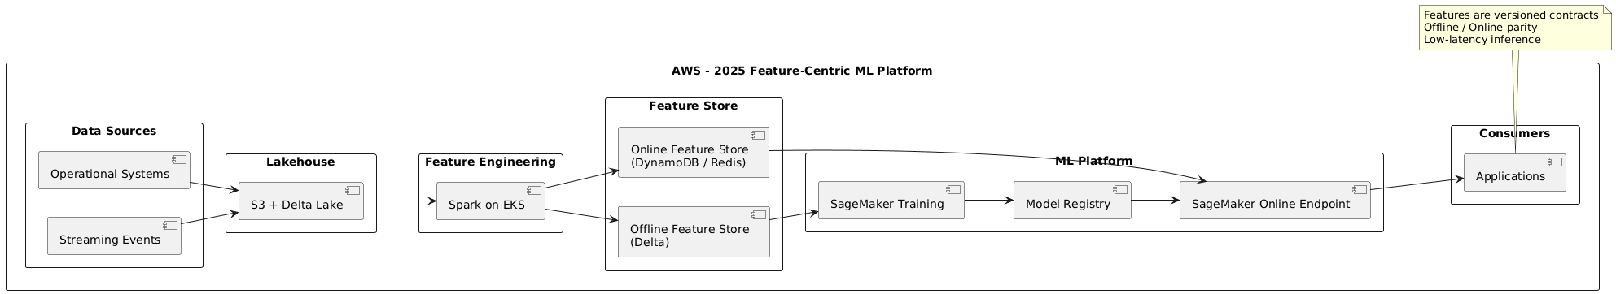
Example of business scenario: Field Operations — Better incident & maintenance recommendations
Scenario
Field technicians upload:
- Inspection reports
- Photos
- Maintenance logs
- Free-text comments
2019 (no training pipeline)
- NLP service extracts keywords
- Classification uses static TF-IDF / rules
- Recommendation engine uses generic similarity
Limitations:
- Cannot learn from actual outcomes
- Same issue described differently → poor matching
- Seasonal patterns not captured
- Recommendations remain generic
This looks similar to previous cases — but not smarter over time.
2025 (with training)
Training data:
- Past incident reports
- Actions taken
- Success / failure outcomes
- Time to resolution
Model learns:
- Which textual patterns lead to failures
- Which fixes worked in which contexts
- Regional / seasonal variations
Benefits:
- Field worker gets:
  - More accurate root-cause suggestions
  - Context-aware recommendations
  - Reduced mean time to repair (MTTR)
Training allows the system to learn from operational history, not just apply generic NLP.
Architecture Diagram Covering Security, Governance & ML Platform (machine learning model training pipeline)
